Betty Jean (Montalbano) Theobold
June 17, 1939 – April 25, 2016

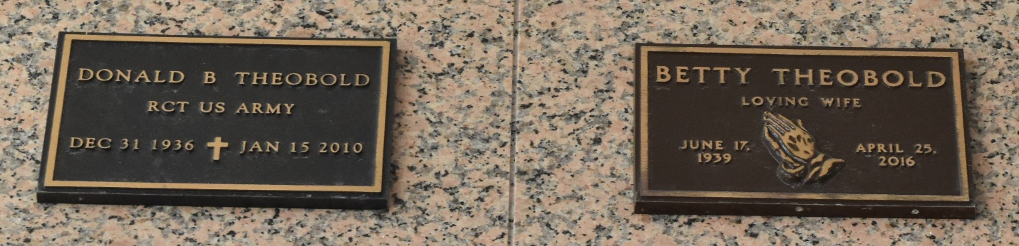

Betty Jean Theobold, entered into eternal rest on Monday, April 25, 2016, at the age of 76.
Daughter of the late Mildred and Sebastian Montalbano. Wife of the late Donald Theobold. Devoted friends Brandon Terrio and Martha Espanaza.
Private burial. Funeral entrusted to The Baloney Funeral Home, LLC, 1905 W. Airline Highway, Laplace, La., 985-224-8460. Condolences can be expressed at www.baloneyfuneralhome.com.

The New Orleans Advocate (LA)
Apr. 29 to May 1, 2016

