Amy Schexnayder (Mahaffey) Thomas
September 24, 1921 – March 29, 2004

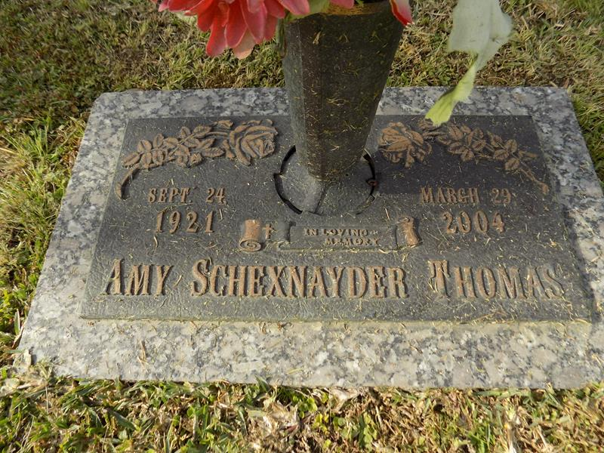

Amy "Peaches" Thomas on Monday, March 29, 2004 at 7:15 p.m. Beloved wife of Bill Thomas. Mother of Ann Ferraro Estey. Grandmother of Nolan and Layle Ferraro. Step-grandmother of Tamara, Jessie and Billie Thomas. Great-grandmother of Manny and Brady Schmidt. Step-mother of Billy and Connie Thomas. Daughter of the late Sam and Mattie Mahaffey. Sister of the late Jesse, Rev. S. W., Claude, James, Printis, Quetta and Ina Mahaffey. Sister-in-law of Marie and Pat Mahaffey. Also survived by loving nieces and nephews. Age 81. A native of Silver Creek, MS and a resident of Tickfaw for the past 14 years.

Relatives and friends of the family are invited to attend services. Visitation at Millet-Guidry Funeral Home, 2806 West Airline Hwy., Laplace on Friday, April 2, 2004 from 5:00 p.m. to 10:00 p.m. and on Saturday, from 8 a.m. to 10 a.m. followed by religious services in the funeral home chapel at 10:00 a.m. Burial in St. John Memorial Gardens Cemetery, Laplace.
Times-Picayune, The (New Orleans, LA)
Wednesday, March 31, 2004
Contributed by Jane Edson

