Ma’zon Malik Thomas
January 6, 2016 – November 11, 2021

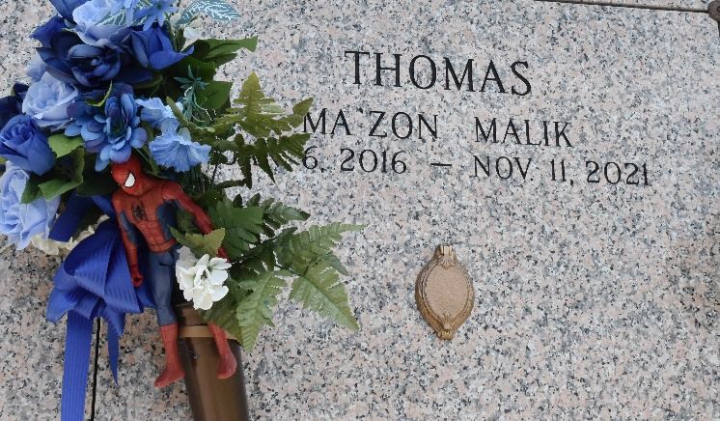

Ma'Zon Malik Thomas was born on January 6, 2016, at Tulane Women's Hospital to Michael Thomas and Tajsha Howard. Ma'Zon attended both day care and pre-school at Garden of Eden Christian Academy, where he graduated from pre-school in June 2021. He also attended Lake Pontchartrain Elementary School and Emily C. Watkins Elementary School.
Ma'Zon enjoyed being active on Tik Tok, watching You-Tube movies, playing football and basketball, and any activity that allowed him to be outside. He played football with the St. John Red Warriors until his brief illness and subsequent death.
On November 11, 2021, Ma'Zon transitioned from this life, as we know it, to a life that is filled with joy everlasting. He was preceded in death by grandfather, Barry Howard; great-grandfather, Barry Holland; great-grandmother, Delores Johnson.
During his short life, he touched many people from various walks of life with his warm personality and his infectious smile. He leaves the following to mourn his transition: mother, Tajsha Howard; father, Michael Thomas; grandmothers, Shantell (Terrence) Samuel and Phoebie Thomas; great-grandmothers, Emelda Walker and Lutha Mason and, great-grandfather, Leonard Dixon of Las Vegas, Nevada. He also leaves to mourn a host of aunts, uncles, cousins; special uncles DeVante Dixon, Travone Bolden, and Richard Jasmine, and special aunts Lakeisha. godmothers and Destiny Burl and Allegra Bovie.
Funeral Service will be held on Saturday, November 20, 2021, at 10:00am at Milesville Memorial C.O.C.I.C., La. Bishop Ronald Frank Officiating, Visitation on Friday from 5-7 and on Saturday from 8-until 11am until service time. Interment in St. John Memorial, LaPlace, LA. Due to CDC (covid19) restrictions seating may be limited, mask and social distancing are required. Professional Services entrusted to the Caring Staff of Hobson Brown Funeral Home. 134 Daisy St. Garyville, La 70051. 985-535-2516.
The Times-Picayune, New Orleans, Louisiana
Nov. 18 to Nov. 20, 2021

