Muriel Mae (Chopin) Thomas
May 22, 1946 – February 17, 2011

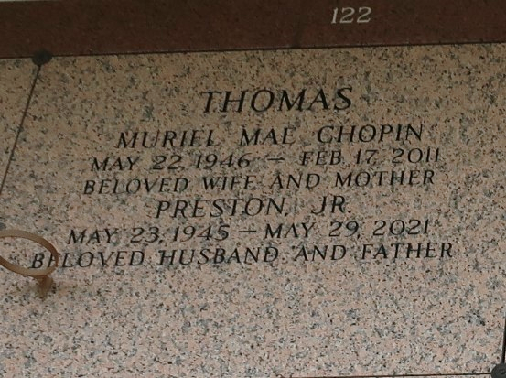

Muriel Mae Chopin Thomas, age 64, passed away peacefully on Thursday, February 17, 2011, in Jefferson, La.
Wife of Preston Thomas Jr. Mother of Penny, Lynn Coy, Randell, Derrick, Dominick, Lakwan and Nicole Thomas. Sister of Jimmy Champion, Annie Carter, Mary Posey, Barbara, Rose, Lillie and Daniel Chopin. Also survived by a host of grandchildren, 2 great-grandchildren, nieces and nephews. A native and resident of LaPlace, LA.

Funeral Service on Thursday, February 25, 2011 at 10:00 a.m., at New Wine Christian Center, LaPlace, La. Rev. Neil Bernard, Pastor - Officiating. Interment in St. John Memorial Garden, LaPlace, La. Viewing at the Church 9:00 a.m. until service time (ONLY). Service Entrusted to Hobson Brown Funeral Home 134 Daisy St., Garyville, La. 70051 Information: (985) 535-2516.
The Times-Picayune, New Orleans, Louisiana
February 23, 2011

