Jermani G. Thompson
October 6, 1995 – August 30, 2022

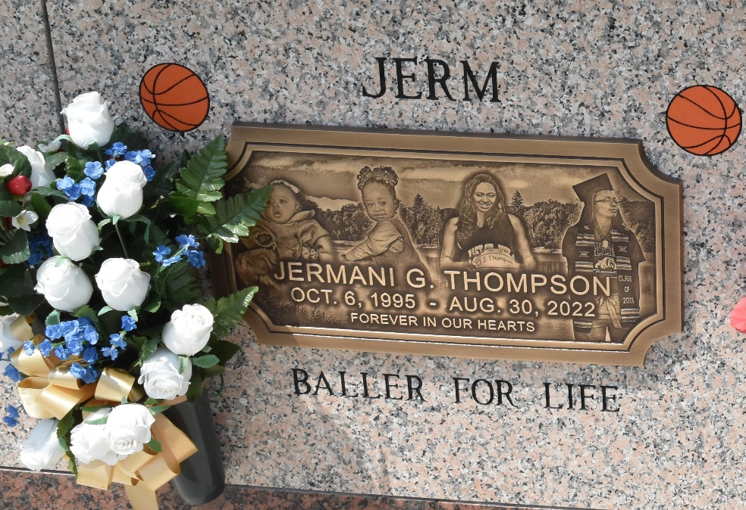

Jermani Germanika Thompson, a 26-year-old vibrant young woman was loved, is missed, and will always be cherished. “Jerm” as she was affectionately called was an amazing daughter, sister, aunt, niece, friend, and incredible basketball player.
Jermani’s story started October 6, 1995. She was the only daughter of Angela Montgomery Dorsey and Eddie Major, Sr., in Laplace, LA, at River Parishes Hospital. She was reared in the River Parishes and matriculated through the public and private school systems of St. John the Baptist Parish. Jermani was a 2014 graduate of East St. John High School. Jermani’s exemplary skills in basketball were evident from a very early age. She loved the game, and the game loved her back. As a result of her dedication and commitment to her craft, she excelled on the court and was able to display her talent and abilities for multiple teams on various levels including biddy basketball, recreation, AAU, Allstar, as well as middle and high school. Jermani’ s awards and accomplishments were many. These included several Most Valuable Player awards, the Reserve Christian School Varsity Girls Basketball Coach’s award, and the Reserve Christian School Varsity Basketball Top Defensive Player award. Jermani also helped lead the East St. John High School Lady Cat Basketball team in becoming District 8-5A Co-Champions. Jermani achieved the next level of excellence as she was recruited and played at Hesston College in Hesston, Kansas. It was there that Jermani earned the Degree of Associate of Arts in 2016. She furthered her academic and athletic journey at Tougaloo College in Tougaloo, Mississippi. She graduated with her Bachelor of Arts in Sociology in 2019.
Although Jermani ultimately dreamed of playing in the WNBA, life took her in a different direction. She was most recently employed with GAT Airline Ground Support. While Jermani’ s death has left her family and friends in disbelief and with an enormous void in their hearts, everyone is thankful for her life. Her heart was big. Her smile and laughter were infectious. She lived life to the fullest and her love for her family was unmatched! Jermani was a bright spark in this world and will be deeply missed by so many.
Jermani transitioned from this earthly life on Tuesday, August 30. 2022. She leaves to cherish her precious memories, her mother and stepfather, Angela M. and Herman Dorsey; father Eddie (Carrie) Major, Sr.; brothers, Demarcus (Nicole) Branch, Eddie Major, Jr., Jarvis Thompson, Cordan Duhe, Edwin and Earon Fisher, and Edward Taylor; sister, En’Janae Taylor; grandmothers Marie Cook Stevenson and Hedy Jo Major; aunts, Yolanda Montgomery, Diane and Betty Major, Eleanor Chester, Zemora Stringer, Earnestine Burge, and Otistine Johnson; uncles, Terrence Thompson, Lance Burfict, IJ and Authur Major; nephews, Chance Armond Lennix, Harlem Branch, Chad Williams, Emmet Lewis, Jr.; nieces, Karmen Major and Tasia, Wynter and Wyndee Fisher; great aunts, Goldie (Clarence) Wilkens and Veronica (Herman) Bailey; great uncle, Elmo (Elsie) Cook; Godchild, Carson Duhe; and a host of cousins, other relatives and friends.
Jermani was preceded in death by her great grandparents, Oscar and Elmer Cook; great grandmothers Elizabeth Alexander and Bernice Hawks; grandfathers, Louis Thompson, Ivy Chester, Sr., and Wesley Stevenson; great uncles, Arthur, Lawrence, Alvin, Henry and Oscar Cook; great aunt, Lizzie Mae Gibson; uncles, Ivy Jr. and Willie, Lawrence and Clarence Chester; aunts, Wanda, Sylvia, Jacqueline and Mary Major; and cousins, Shannon Thompson and Rome Major.
Relatives and friends of the family, also Pastors, Officers and Members of Destiny Christian Center, New Wine Christian Fellowship and all neighboring churches are invited to the Celebration of Life on Saturday, September 17, 2022, 10:00am at New Wine Christian Fellowship, 1929 W. Airline Hwy, Laplace, LA 70068. Pastor Steve O. Allen of Destiny Christian Center-Officiant, Pastor Neil Bernard-Host Pastor. Visitation 8:00am until time of service. In accordance with the CDC guidelines for COVID-19 all in attendance must wear mask and practice social distancing. Interment St. John Memorial Gardens, 2205 W. Airline Hwy, Laplace, LA 70068. Final Arrangements Entrusted to Patrick H. Sanders Funeral Home & Funeral Directors, Inc. 605 Main Street, Laplace, LA 70068. For information 985-359-1919.
The Patrick H. Sanders Funeral Home, LaPlace, Louisiana

