David L. Timberlake Sr.
February 21, 1952 – September 24, 2015

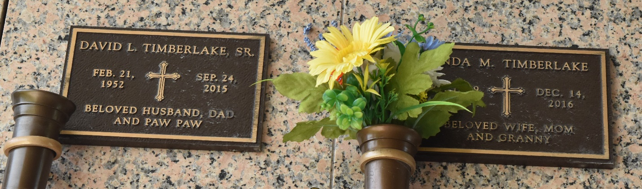

David L. Timberlake, Sr. passed away on Thursday, September 24, 2015. He was 63, a native of Ponchatoula, LA, and a resident of LaPlace, LA. Beloved husband of Linda Madere Timberlake. Father of Lori Roussel, Tricia Bourgeois, Brandi Timberlake, Katie Caillouet, David "D.J." Timberlake, Jr. and Aimee Lee. Son of the late Beulah Drury and Edward Timberlake. Brother of Martha "Micky" Sullivan, Joyce Rushing, Stanley Timberlake, Harvey Timberlake and the late Shirley Scioneaux, Betty Huber. Also survived by 11 grandchildren and many nieces and nephews.

Relatives and friends are invited to attend the Graveside Service on Wednesday, September 30, 2015, 11:00 a.m. at St. John Memorial Gardens. To view or sign the online guest book, please visit www.milletguidry.com.

The New Orleans Advocate (LA)
Sep. 27 to Sep. 29, 2015

