Linda (Madere) Timberlake
Abt. 1952 – December 14, 2016

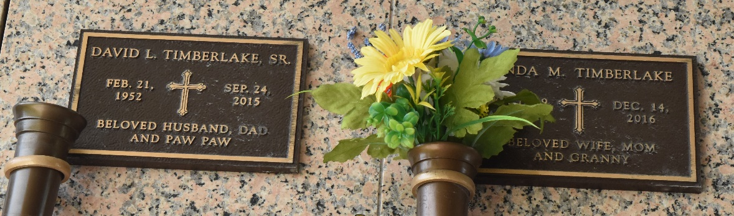

Linda Madere Timberlake passed away on Wednesday, December 14, 2016. She was 64, a native and resident of LaPlace, LA.
Beloved wife of the late David L. Timberlake, Sr. Mother of Lori Roussel, Tricia Bourgeois, Brandi Timberlake, Katie Caillouet, David 'DJ' Timberlake, Jr. and Aimee Lee. Daughter of the late Lillian Badeaux and Noe Madere, Sr. Sister of Burton Madere, Gary Madere and the late N.J. Madere and Harold Madere. Also survived by 12 grandchildren and many nieces and nephews.
The family would like to extend their heartfelt appreciation to Leigh L. Hoover for her loving care.
Relatives and friends are invited to attend the Memorial Service at Millet-Guidry Funeral Home, 2806 W. Airline Hwy, LaPlace, LA on at Saturday, December 17, 2016 at 11:00 a.m. Visitation from 10:00 a.m. until 11:00 a.m. Inurnment in St. John Memorial Gardens. To view or sign the online guest book, please visit www.milletguidry.com.

The New Orleans Advocate (LA)
Dec. 15 to Dec. 17, 2016

