Nathaniel Todd
June 15, 1985 – May 12, 2006

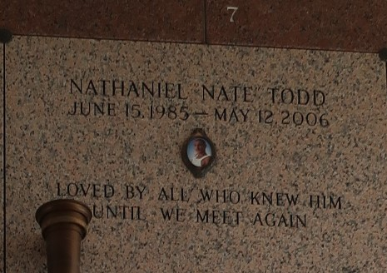

Nathaniel (Nate) Todd on Friday, May 12, 2006 at 2:15 a.m.
Beloved son of John and Karen Blank. Brother of Kristyn Yager and Lindsay Blank. Fiancee' of Ramsi Revon. Father of Myracle Revon. Age 20. A native and resident of LaPlace.
Relatives and friends of the family are invited to attend services. Visitation at Millet-Guidry Funeral Home, 2806 West Airline Highway, LaPlace on Thursday, May 18, 2006 from 11am to 1pm. Followed by religious services in the funeral home chapel at 1:00 pm. Burial in St. John Memorial Gardens, LaPlace.

The Times-Picayune, New Orleans, Louisiana
May 17, 2006

