Carolyn (Cooper) Torrence
June 18, 1947 – December 26, 2000

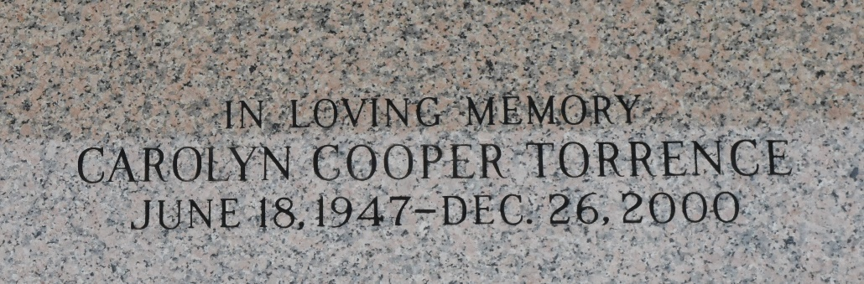

Carolyn Cooper Torrence, 53, a native of Gramercy and resident of Kenner, died Dec. 26.
She was the wife of Elzy Torrence and mother of Travis Torrence. She was also the sister of Betty Coleman, Jacqueline Mattos, Lily Teague, Beverly Johnson, Donna Williams and Ricky Cooper. She was a teacher in the St. James Parish school system.
Services were Dec. 30 at the Jehovah's Witness Kingdom Hall, LaPlace, with interment at St. John Memorial Garden, LaPlace.
L'Observateur, LaPlace, Louisiana
January 2001

