Idalgo Tosi
April 22, 1937 – October 28, 2017

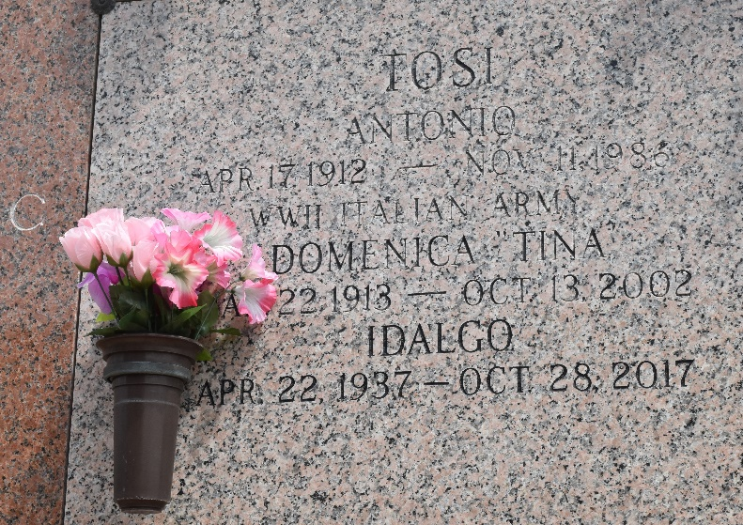

Idalgo Tosi passed away on Oct. 28, 2017, at the age of 80 from complications of a massive stroke.
He was born in Savignano sul Rubicone, Italy, and legally immigrated to America in 1956. Idalgo lived and worked in Racine, Wisconsin, for many years where he was sole proprietor of Racine Tailor Shop. Later, he was employed at Macy’s at the Esplanade Mall in Kenner in the alterations department. In his leisure time Idalgo enjoyed dancing at Club Silhouette in Metairie, and Rock ‘n Bowl in New Orleans.
He was preceded in death by his father, Tony Tosi, and his mother, Tina Tosi. He is survived by his sister, Terri Prough (Tom), nephew Aaron Prough, nephew Derek Prough (Mariana) and great niece Emilia Prough. He has many cousins and other relatives living in Italy. His ashes will be taken back to Italy and buried at a later date.
The family wishes to acknowledge Chateau St. James Nursing Home in Lutcher for the comfort and loving care he received from the Nurses, CNAs, housekeeping and cooks.
Relatives and friends are invited to attend the Visitation at 9 a.m. Saturday, Nov. 18 at Ascension of Our Lord Church, 1900 Greenwood Drive in LaPlace. Mass will follow Visitation at 10 a.m.

L’Observateur, LaPlace, Louisiana
Monday, November 13, 2017

