Jared R. Townsend
1981 – April 17, 2011

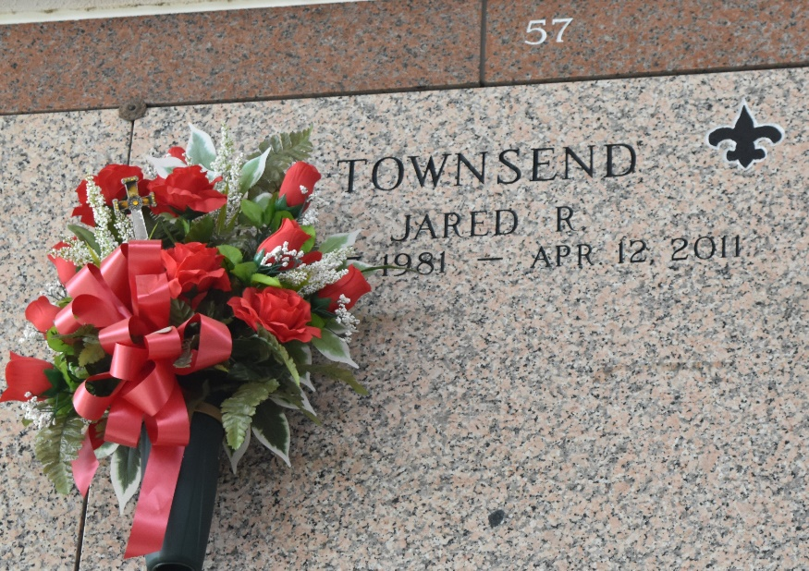

Jared Townsend passed away on Tuesday, April 12, 2011. Beloved father of Cole Townsend. Son of Jan Clement Townsend and Gary Townsend. Brother of Tammy T. Rose. Grandson of Carmelite Clement and the late William Clement Jr. Age 29. A native and resident of LaPlace, LA.
Relatives and friends are invited to attend services. Visitation at Millet-Guidry Funeral Home, 2806 W. Airline Hwy., LaPlace, LA on Thursday, April 14, 2011 from 5:00 pm to 9:00 pm and on Friday from 8:00 am to 9:30 am followed by Mass at St. Joan of Arc Catholic Church, LaPlace, LA at 10:00 am. Burial in St. John Memorial Gardens Cemetery, LaPlace, LA.

The Times-Picayune, New Orleans, Louisiana
Apr. 14, 2011

