Anna Lee (Schexnayder) Trafficano
January 30, 1941 - May 4, 2019

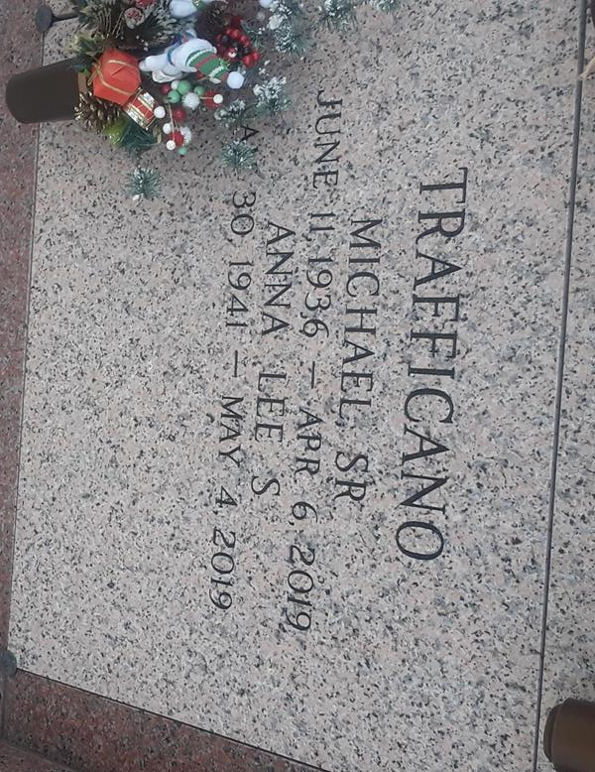

Anna Lee Schexnayder Trafficano went in peace to join the Lord surrounded by her family on Saturday, May 4, 2019. She was 78, a native and life-long resident of LaPlace, LA.
Beloved wife of the late Michael Trafficano, Sr. Beloved mother of Michael Trafficano, Jr. (Melissa), Tammy Murphy (Patrick), Barry Trafficano and Hope Duhe (Brad). Grandmother of Angel McLemore (Randall), Alicia Wheeler (Chris), Alana Justice (Shane), Erin Trafficano, Ashley Duhe and Emily Duhe. Great-grandmother of Brayden and Landen McLemore and Marissa and Maddy Wheeler. Daughter of the late Carmelite and Elmo Schexnayder. Sister of Drexel Schexnayder (Wanda Faye), the late Elmore Schexnayder (late Dorothy) and the late Grace Roussel (Gerald). Also survived by many nieces and nephews.
The family would like to express their heartfelt appreciation to her sitters past and present for their loving care and to Mr. Al and Dr. Bobby Ory for bringing communion every week.
Relatives and friends are invited to attend the Funeral Mass at St. Joan of Arc Catholic Church, 529 W. 5th Street, LaPlace, LA on Friday, May 10, 2019 at 12:30 p.m. Visitation at the church from 10:30 a.m. until 12:30 p.m. Interment in St. John Memorial Gardens Cemetery.

Millet-Guidry Funeral Home, LaPlace, LA
May 7, 2019

