Michael Trafficano Sr.
June 11, 1936 – April 6, 2019

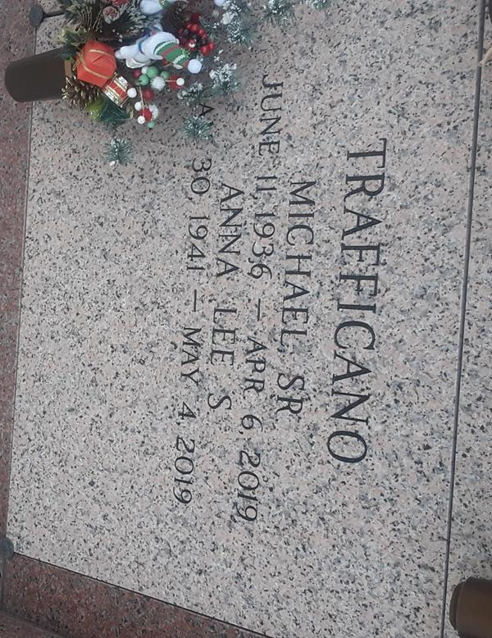

Michael Trafficano, Sr. went in peace to join the lord surrounded by his family on Saturday, April 6, 2019. He was 82, a native and life-long resident of LaPlace, LA.
Beloved husband of Anna Lee Schexnayder Trafficano. Beloved father of Michael Trafficano, Jr. (Melissa), Tammy Murphy (Patrick), Barry Trafficano and Hope Duhe (Brad). Grandfather of Angel McLemore (Randall), Alicia Wheeler (Chris), Alana Justice (Shane), Erin Trafficano, Ashley Duhe and Emily Duhe. Great-grandfather of Brayden and Landon McLemore and Marissa and Maddy Wheeler. Son of the late Santa Angelica Trafficano and Servario Trafficano. Brother of Annie Sanders (Paul) and the late Joseph Trafficano(the late Anges), Bernard Trafficano (Ella), Jake Traffiano (the late Grace), Calorie Trafficano (the late Lillie), Tommy Trafficano, Josephine Saragusa (the late Carlo), Lucy Vicari (the late Lawrence), Geraldine Hedges (Joe) and Eileen Trafficano. Also survived by many nieces and nephews.
The family would like expressed their heartfelt appreciation to St. Catherine Hospice and his sitters past and present for their loving care and to Mr. Al and Dr. Bobby Ory for bring communion every week.
Relatives and friends are invited to attend the Funeral Mass at St. Joan of Arc Catholic Church, 529 W 5th Street, LaPlace, LA on Saturday, April 13, 2019 at 11:00 a.m. Visitation at the church from 9:00 a.m. until 11:00 a.m. Interment in St. John Memorial Gardens Cemetery.

Millet-Guidry Funeral Home, LaPlace, Louisiana
April 9, 2019

