Effie (Boudreaux) Triche
December 28, 1916 – May 29, 2003

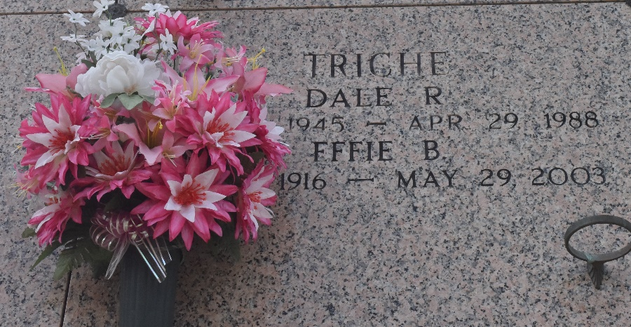

Effie Boudreaux Triche, On Thursday, May 29, 2003 At 11:10 Pm, Beloved Wife Of The Late Ernest Joseph Triche, Sr. Mother Of Dolores T. Jacob, Geraldine T. Scioneaux, Gale Triche Baker, Bonnie Triche Clement, Ernest Joseph Triche, Jr., Carroll James Triche And The Late Joann Triche Bossier And Dale Richard Triche. Mother-In-Law Of Geraldine Ordeneaux And Brenda Deaton Triche, Leroy J. Bossier, James C. Jacob, L.T. Scioneaux, Barry Clement, John Baker, David Gauthe', Sr. And Terry Roussel, Sr. Daughter Of The Late Sylvain And Lea Trosclair Boudreaux. Sister Of The Late Sylvain, Jr., Joel, Hadis, Sylvania, Aline, Adline And Lena Boudreaux. Also Survived By 25 Grandchildren, 42 Great-Grandchildren
And 5 Great-Great-Grandchildren. Age 86 Years. A Native Of Chackbay, La. And A Resident Of Laplace For The Past 63 Years.
Visitation At St. Joan Of Arc Catholic Church, Laplace, La. On Monday, June 2, 2003 From 9 Until 11 Am, Followed By Religious Services At 11 Am. Burial In St. John Memorial Gardens, Laplace, La.
Family Wishes To Express Appreciation To Twin Oaks Nursing Home And Their Staff And Her Friends There For The Care Given To Their Mother And Invite Them To Attend The Services. Arrangements By Millet Guidry Funeral Home, Laplace, La.
Times Picayune, New Orleans, Louisiana
May 31, 2003

