Jeremy Michael Triche
September 18, 1936 - October 6, 2019

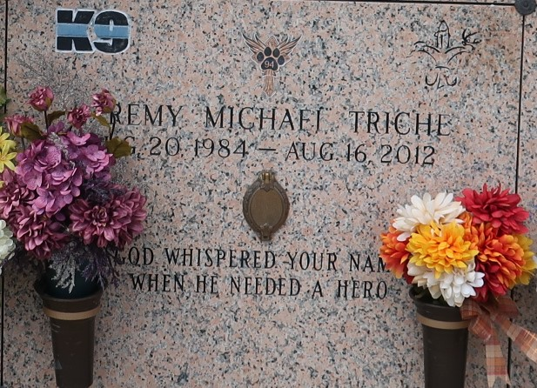

Deputy Sheriff Jeremy Triche and Deputy Sheriff Brandon Nielsen were shot and killed in LaPlace, Louisiana, by members of a domestic terrorist group known as the Sovereign Citizens. They were shot while investigating an earlier ambush shooting that wounded a sheriff's office investigator.
The investigator was working an off-duty security detail at a remote employee parking lot used by a construction company at about 5:00 a.m. when he was ambushed as he sat in his department vehicle.
Responding units located a car they believed had been involved in the early shooting in a nearby trailer park. As Deputy Nielsen, Deputy Triche, and a third deputy questioned two men outside of a mobile home, a third man suddenly exited the home and opened fire with a semi-automatic rifle, striking all three deputies. Deputy Nielsen and Deputy Triche both died as a result of their wounds.
Seven subjects were arrested and held in connection with both separate shooting incidents. The shooter was sentenced to death on Feb. 9, 2020.
Deputy Triche had served with the St. John the Baptist Parish Sheriff's Office for four years. He is survived by his wife and 2-year-old son.

Source: Deputy Sheriff Jeremy Michael Triche, St. John the Baptist Parish Sheriff's Office, Louisiana (odmp.org)
**

Jeremy Michael Triche passed away on Thursday, August 16, 2012. Husband of Misty McTopy Triche. Father of Kade Michael Triche. Son of Michael and Edie Klibert Triche. Brother of Jared Triche (Whitney). Grandson of Dorrel and Mary Lambert Triche, Ruth Klibert Cardinale and Gerald Klibert, Sr. Son-in-law of Sherry Whittington McTopy and the late Joel S. McTopy. Brother-in-law of Shelley McTopy St. Pierre. Uncle of Jordan and Gavin St. Pierre. He also leaves behind his K-9 partner, Jango.
Age 27 years. A native and resident of LaPlace, LA. A graduate of St. Charles Catholic High School (2004) and Southern Arkansas University (2008)
Relatives, friends, St. John the Baptist Sheriff Office and fellow law enforcement officers are invited to attend services. Visitation at New Wine Christian Fellowship, 1929 Airline Hwy., LaPlace, LA on Sunday, August 19, 2012 from 5:00PM until 9:00PM and on Monday from 9:00AM until 10:30AM. Followed by Mass at 11:00AM at St. Joan of Arc Catholic Church, 529 W. 5th Street, LaPlace, LA. Burial in St. John Memorial Gardens Cemetery, LaPlace, LA. In lieu of flowers, donations can be made to the Jeremy Triche Memorial Fund c/o Louisiana Federal Credit Union, 350 Belle Terre Blvd., LaPlace, LA 70069. Arrangements by Millet-Guidry Funeral Home, LaPlace, LA.

The Times-Picayune, New Orleans, Louisiana
Aug. 17 to Aug. 19, 2012

