Mary Ruth (Edwards) Triche

March 8, 1930 – September 22, 2013

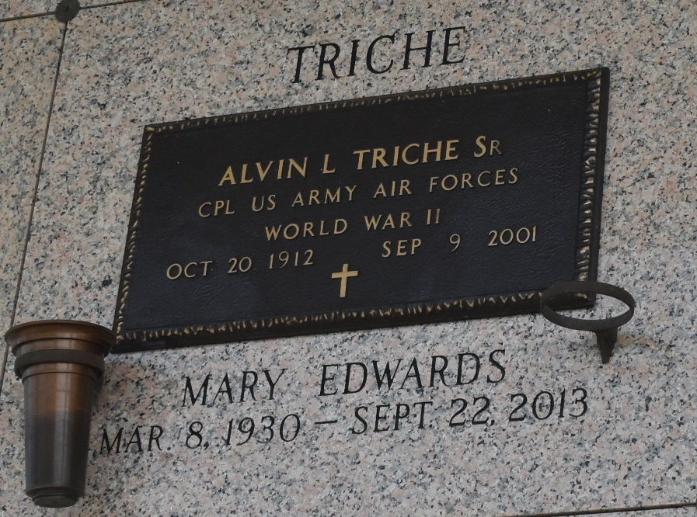

Mary Ruth Edwards Triche, 83, died Sunday, Sept. 22, 2013.
She was the beloved wife of the late Alvin “Cap” Triche, mother of Alvin Triche (Cathy), Margaret Landry (Chuck) and Carol Keating (Lawrence Jr.), grandmother of Janelle Williams, Stacy Remondet, Ali Giles, Christy Castro, Clint Landry, Chantelle Roussel, Kelly Triche and Kayla Whitney, great-grandmother of Drey Triche, Lakin and Christian Wood, Carmen Giles, Alexis Remondet, Isabella Cline, Zander Landry, Paige and Kelsie Williams, Luke and Lanie Whitney, Kellen Frasier and Cori and Caroline Brignac and daughter of the late John and Marinda Pettis Edwards. She was a native of Mississippi and resident of LaPlace.
Visitation and services were held at Millet-Guidry Funeral Home of LaPlace on Wednesday, Sept. 25, 2013. Burial followed in St. John Memorial Gardens Cemetery in LaPlace.

L’Observateur, LaPlace, Louisiana
Friday, September 27, 2013

