Sidney Joseph Triche
January 3, 1956 – September 18, 2012

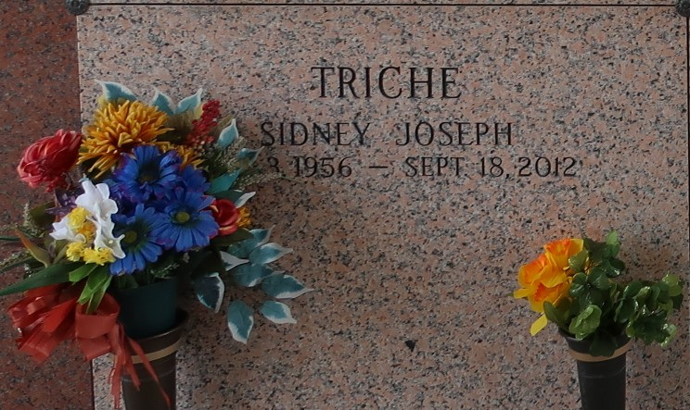

Sidney J. Triche passed away on Tuesday September 18, 2012. Beloved husband of Nida W. Triche. Beloved father of Sidney W. Triche, Chasity Triche and Jason L. Triche (Melissa). Grandfather of Peyton Triche and the late Destiny Champagne. Son of Larry Triche and the late Edna Mae Trosclair Triche. Brother of Michael Triche. Also survived by nieces and nephews. Age 56. A native and a resident of LaPlace, LA.
Relatives and friends are invited to attend services. Visitation at Millet-Guidry Funeral Home, 2806 W. Airline Hwy. LaPlace, LA on Friday September 21, 2012 from 8:00 am to 9:45 am, followed by Religious Services in the Funeral Home Chapel at 10:00 am. Burial in St. John Memorial Gardens, LaPlace, LA. In Lieu of flowers donations preferred to The St. John Deputies Fund at The LA Federal Credit Union, LaPlace, LA.

The Times-Picayune, New Orleans, Louisiana
September 19-20, 2012

