Dora Lopez Trichell
September 18, 1936 - October 6, 2019

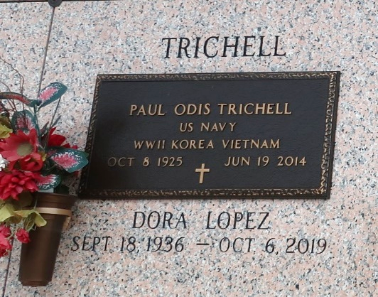

Dora Lopez Trichell passed away on Sunday, October 6, 2019 at the age of 83. She was a native of Kingsville, TX and a resident of LaPlace since 1968. Dora was a parishioner of Ascension of Our Lord Catholic Church and a former parishioner of St. Joan of Arc Catholic Church. She was a founding member of the Monday night Rosary Group and a volunteer at River Parishes Hospital. Prior to retirement she was the activities coordinator at Place Du Bourg and was an avid gardener. Dora’s gift of love for people and kind spirit remained throughout her battle with Alzheimers.
Beloved wife of the late Paul O. Trichell. Loving mother of Susan Trichell Major and Steve Trichell (Tammy). Grandmother of Jarrett and Justin Major and Kristen, Lauren and Karen Trichell. She is also survived by her brother, Julius Briones; sister-in-law, Lupita Lopez; and many cherished nieces and nephews. She was preceded in death by her parents, Natividad “Nat” Lopez and Nicolasa Curiel Lopez; brother, Larry Lopez; and sister, Sylvia Lopez Belt.
Relatives and friends are invited to attend the Funeral Mass at Ascension of Our Lord Catholic Church, 1900 Greenwood Dr., LaPlace on Saturday, October 12, 2019 at 12:00 p.m. Visitation will be held in church from 10:00 a.m. to 12:00 p.m. Interment to follow in St. John Memorial Gardens Cemetery.

Millet-Guidry Funeral Home, LaPlace, LA
October 8, 2019

