Paul Odis Trichell

October 8, 1925 – June 19, 2014

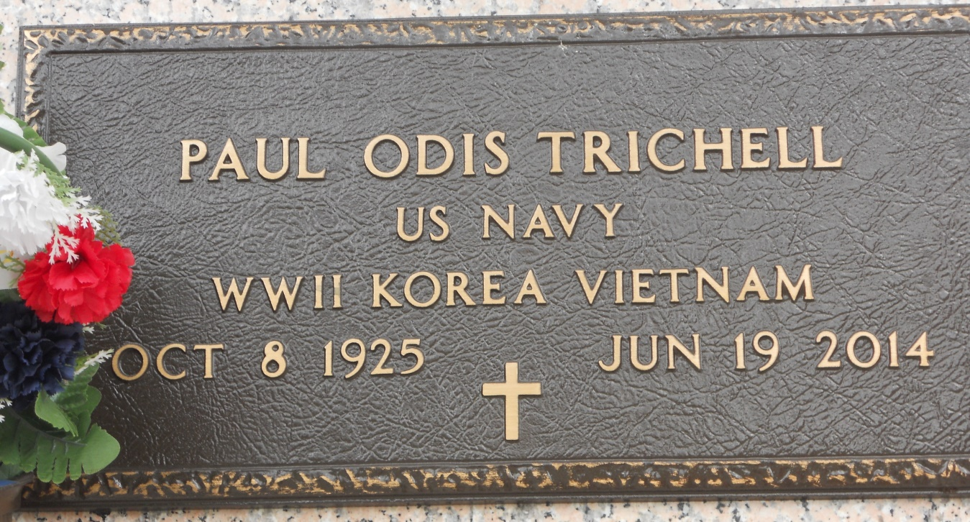

Photo by Team T Lo

Paul O. Trichell died on Thursday, June 19, 2014. Beloved husband of Dora Lopez Trichell. Father of Susan Trichell Major and Steve Trichell (Tammy). Grandfather of Jarrett and Justin Major and Kristen, Lauren and Karen Trichell. Survived by sister Josephine Kohler and Brother-in-law Julius Briones. Also survived by numerous cherished nieces and nephews.

He retired from the US Navy and a Veteran of WW II, Korea and Vietnam. Age 88. A native of Oak Grove and a resident of LaPlace, LA.

Relatives and friends are invited to attend services. Visitation at Ascension of Our Lord Catholic Church, 1900 Greenwood Dr, LaPlace, LA on Saturday June 21, 2014 from 9:00am to 10:00am followed by Mass at 10:00am. Burial in St. John Memorial Gardens, LaPlace, LA. Arrangements by Millet-Guidry Funeral Home, LaPlace, LA.

Advocate, The (Baton Rouge, LA) - Friday, June 20, 2014

Contributed by Jane Edson