James Donald Trosclair
September 19, 1936 – January 12, 2018

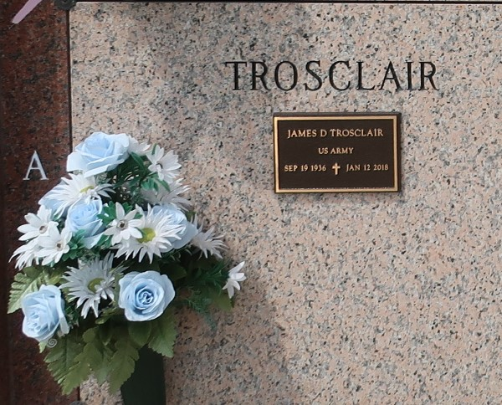

James Donald Trosclair, born on September 19, 1936 and died at the SE LA War Veterans Home on January 12, 2018. He proudly served our country in the US Army from 1956 - 1959. He was 81, a native of Reserve, LA and a resident of LaPlace, LA.
He leaves behind his loving wife Carole Troxclair Trosclair of more than 60 years. Loving father of James Trosclair, Jr. (Lisa) of Paulina, LA, Jared Trosclair (Tina) of Norco, LA, John Trosclair (Honey) of Gonzales, LA, Lisa Laiche (Gary) of Gonzales, LA, Amy Tregre (Steven) of Reserve, LA, Tracy Tregre (Glenn) of Albany, LA and Cheryl Marie Trosclair of Garyville, LA. Son of the late Emma Gueret Trosclair and Fred Paul Trosclair, Sr. Brother of Leda Mae Steib and the late Eldon Trosclair, Fred Trosclair, Jr., Annie Scioneaux and Adam Trosclair. Also survived by 18 grandchildren, 24 great-grandchildren, 1 great-great-grandson and many nieces and nephews.
Relatives and friends are invited to attend the Funeral Mass at Ascension of Our Lord Catholic Church, 1900 Greenwood Dr., LaPlace, LA on Monday, January 15, 2018 at 11:30 a.m. Visitation from 9:30 a.m. until 11:30 a.m. Interment in St. John Memorial Gardens Cemetery. Arrangements by Millet-Guidry Funeral Home.

Millet-Guidry Funeral Home, LaPlace, Louisiana
January 14, 2018

