Richard C. Troxclair
December 6, 1977 – January 18, 2022

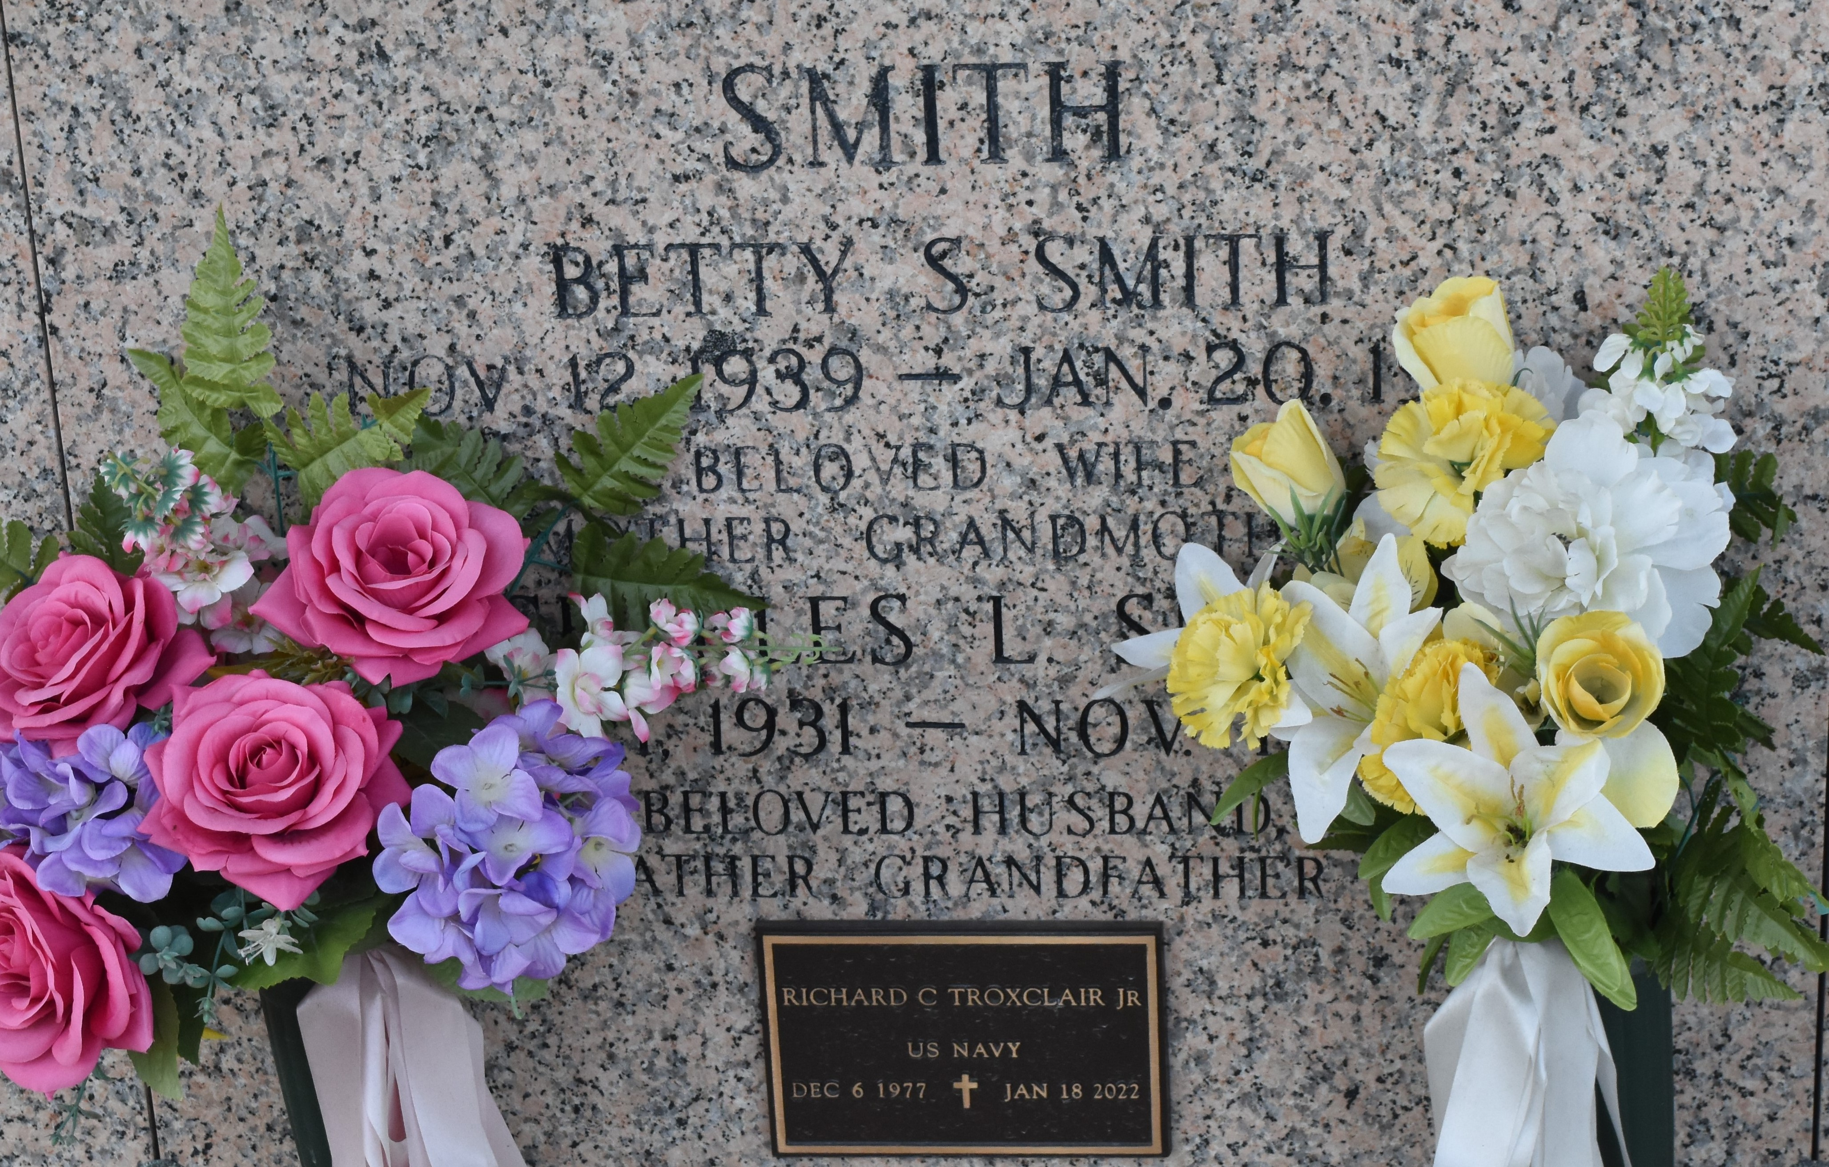

Richard Charles Troxclair, Jr. passed away on Tuesday, January 18, 2022, at the age of 44. Richard was a native of LaPlace, LA and a lifelong resident of New Sarpy, LA. He served in the U.S. Navy from 1995 - 2003. Richard worked at Riverlands Country Club and most recently at Audubon Country Club. A couple of his favorite hobbies were reading and building model replicas. The loving son of Richard Charles Troxclair, Sr. (Tammy) and Susan Tubre (Bob). Brother to Elizabeth Slocum (James) and Timothy Troxclair (Kristine). Uncle to Cody Troxclair, Richard Tindale and Hudson Troxclair. Also survived by Randy and Val Smith along with other relatives and friends. A private service will be held at a later time. Arrangements by Millet-Guidry Funeral Home.

The Times-Picayune, New Orleans, Louisiana
Jan. 22 to Jan. 23, 2022

