Lester Patman Tucker
August 7, 1952 – April 24, 2003

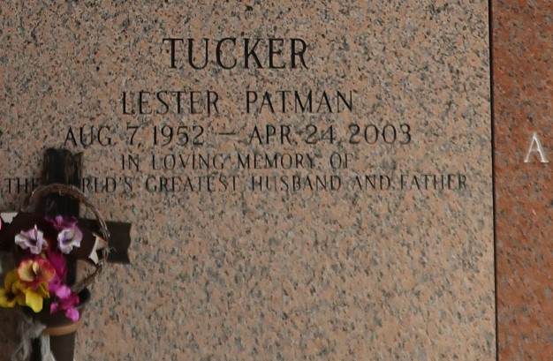

Lester Patman Tucker passed away on Thursday, April 24, 2003 at St. Charles Hospital in Luling. Aged 50 years. He was a native of Ft. Worth, TX and a resident of New Sarpy, LA. Mr. Tucker was an operator at Shell Oil Co.
Beloved husband of Mary Caillouet Tucker. Son of James Patman Tucker and mother, Betty Jo Riley and raised by an aunt, Tessie Scott. Father of Lester Patman Tucker, Jr., Jeremy Glenn Tucker, Kyle D'Wayne Tucker, and Angela Ellen Tucker Johnson. Brother of James Allen Tucker and Debra Lynn Foster. Grandfather of Alyssa Nicole Wininger, Caryn Elizabeth Tucker, Javin Mician Tucker and soon to be a fourth grandchild.
Family and friends are invited to attend the funeral services at Reserve Christian Church, 3556 W. Airline Hwy., Reserve, LA on Monday, April 28, 2003 at 11:30 A.M. Visitation will be held at the church on Monday from 9:30 A.M. until service time. Interment will be at St. John Memorial Gardens, LaPlace, LA. Arrangements under the direction of H.C. ALEXANDER FUNERAL HOME, 821 Fourth St., Norco, LA. Info: 985-764-6249.

The Times-Picayune, New Orleans, Louisiana
April 27, 2003

