Andrew Tuircuit Sr.
December 23, 1951 – October 1, 2022

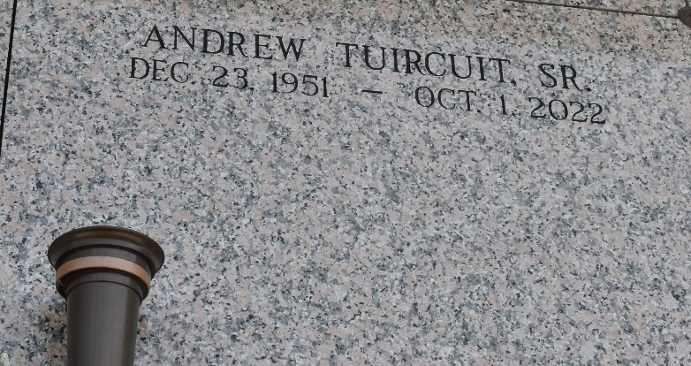

Andrew Tuircuit Sr. was born on December 23, 1951 to Everage Sr. & Magary Thompson Tuircuit in New Orleans Louisiana. Our beloved husband, father, grandfather & uncle-departed this earthly life on October 01, 2022 at the age of 70. He was an inspiration and blessing to all who knew him. If he had it to give, he would never let anyone go without. We will forever remember that beautiful smile on his face. Andrew always had a kind word and giving heart. Andrew affectionally known to some as "Zeek" and to others as "Boise." He was educated at Our Lady of Grace Catholic School & Fifth Ward High. His love for music was known throughout the River Parishes. He played music with several local bands as a drummer. His favorite solo artist was George Benson. He was employed by BOH Brothers & T.L. James (James Construction) until he retired. His enjoyment after retirement was sitting on the porch and under the pecan tree enjoying family & friends. You would always see him riding his bike, visiting family only to chat over a cup of coffee.
On February 17, 1973 Andrew married his first love Vallery Toney. To that union they were blessed with one son Andrew "Pep" Tuircuit Jr. Years later God blessed Andrew to meet & marry Catherine Patterson.
Left to cherish his memories are his wife-Catherine Tuircuit, his sons Andrew Tuircuit Jr. (Joycelyn), Deon Tuircuit & Dennis Neal Jr. His daughter's- Nicole Mitchell, Kendra Mitchell & D'Vana Tuircuit Sanders (Antonio). Bonus daughter-in-law-Shareen Tuircuit. His Sister - Margery Tuircuit-Wilkins- Sister-in-law's- Louise Batiste-Tuircuit, Meshelle Kelson, Lois Mcknight, Ceolia Patterson, Mala Taylor (Robert), Terry Jones (Late Edmond), Mother-in-law- Rosemary Toney (Late-Pershing Toney Sr.), Alena Griggs (Michael) Brother-in-law's- Gerald Patterson Sr., Andrew Sanders & Pershing Toney Jr. (Deidre). He was blessed with beautiful grandchildren - Lakendralyn Riley, Tyren Riley, Jakira Mitchell, Jamikalyn Riley, Asante Alexander, Tre'Shayne Tuircuit, Ty'ree Tuircuit, Ty'Jna Tuircuit, Aleshia Murry Lewis (Ashton), Jamari Nelson, Tiana Nelson, Carl Foster III, Carlie Foster, A'hadah Tuircuit, Walter Tuircuit Sr., & Dennis Neal Jr. Greatgrand children- Krystianna Riley, Kaiden Lewis, Ashton Lewis Jr., Aiden Alexander, Demarco Nash, Germoni Green, Walter Tuircuit Jr. Kaide Neal & Dennis Neal III.
Andrew was proceeded in death by his parents-Everage & Magary Tuircuit, his late wife Valery Tony Tuircuit, Grandparents-Alida Mercier Thompson & Andrew Thompson - Grandmother - Irene Zeno. Siblings- Everage Jr (Diane) & Michael Tuircuit, Shirleen Tassin (Ernest), Catherine Cook, Sophia Bovie, & Sylvia Tuircuit. Mother & Father-in-law- Mable Preston & Pirl Patterson, Brother in-laws-Almo Patterson, Clifton Patterson, Charles Patterson, Clerance Stevens & Clay Wilkens. Nephew's - Shannon Tassin Sr., Darryl Tuircuit, & Dedrick Tuircuit, Niece-Cathy Jones - 3 Great nephews & 4 Great nieces. And a host of Brother-in-laws, Sister-in-laws, nieces, nephews, other family members and friends. Truly, Andrew will be greatly missed by his family, friends, neighbors, and members of Tchoupitoulas Chapel.
Patrick H. Sanders Funeral Home, LaPlace, Louisiana
October 27, 2022

