W. Robert Tuson

July 27, 1918 – October 27, 2001

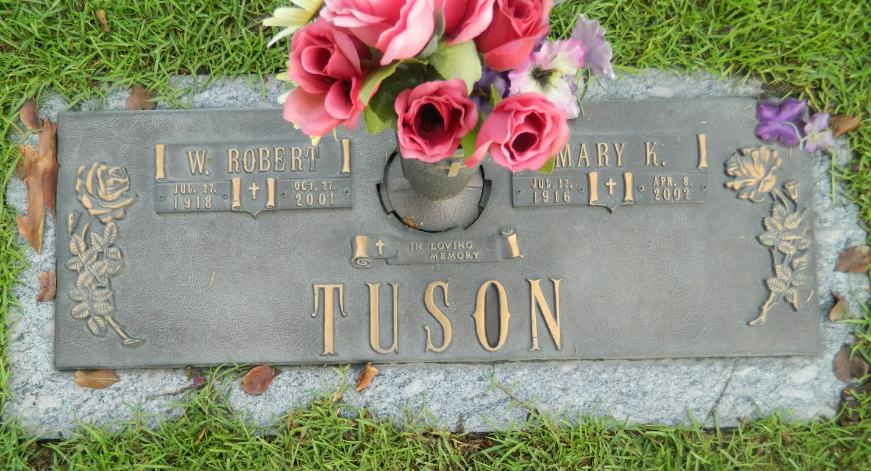

Photo by Margie Pearce

W. Robert Tuson, 83, a native of Newark, N.J., and resident of LaPlace for 18 years, died Oct. 27. He was the husband of Mary Kelley Tuson and father of Katherine and William Tuson. He was a magna cum laude graduate of Notre Dame University with a bachelor of science in chemical engineering and a retired vice-president of Colonial Sugar in Gramercy. Services are today at 11 a.m. at St. Joan of Arc Catholic Church, LaPlace, with interment at St. John Memorial Gardens, LaPlace. Visitation 9 a.m.

L'Observateur, LaPlace, LA; November 3, 2001