Ashley Trenell (Favorite) Tyler
July 7, 1985 – June 24, 2018

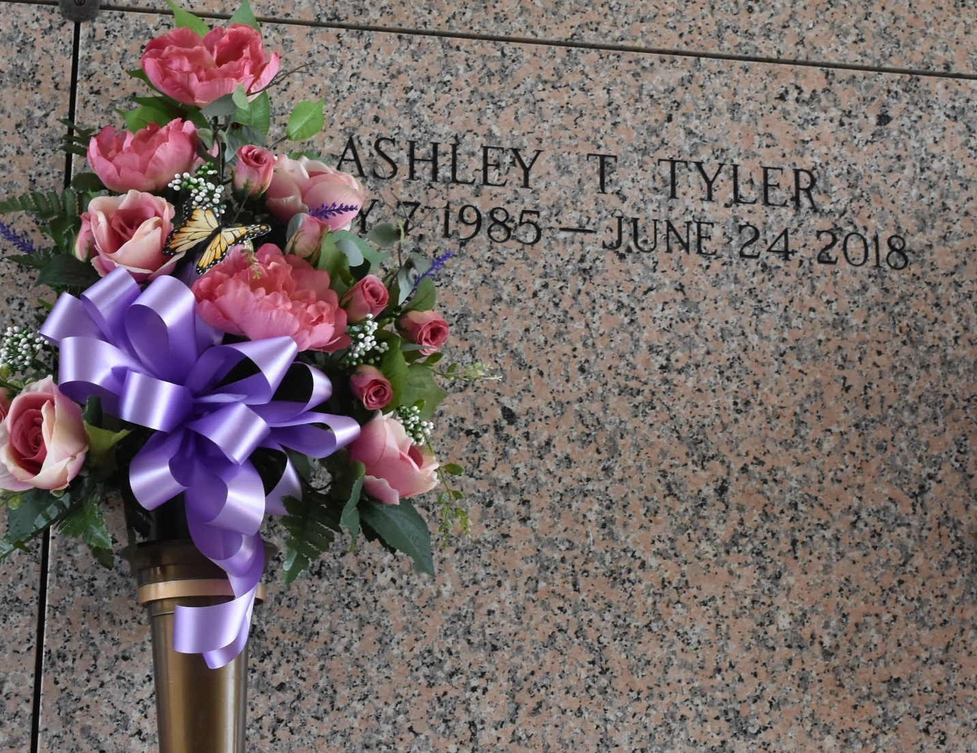

Ashley Favorite Tyler, was born on July 7, 1985 to Pamela Varnado (Charles) and to the late James Favorite and baptized at an early age at Mt. Zion #1 Baptist Church. She departed her earthly life on Sunday June 24, 2018.
Beloved wife of Tornell Tyler Sr.; mother of Tornaja Tyler and Tornell Tyler Jr.; sister of Tiesha Claiborne, Javon Favorite (Dartania), Shaine Ingram, Tayanesha, Tajuan, Jamie, Brielle and Ormoni Favorite; sister-in-law of Rydell Ursin (Toya); grand-daughter of Gussie Preston, the late Nolan Preston Sr. and the late Lucile and James Favorite Sr. She also leaves a host of aunts, uncles, nieces and nephews and cousins.
Funeral services will be held on Thursday, July 5, 2018 for 12:00 noon from Treasures of Life Funeral Services. 315 E Airline Hwy, Gramercy, LA 70052. Visitation from 10:00am until service time. Interment St. John Memorial Garden, LaPlace, LA.
Treasures of Life Funeral Services, Gramercy, Louisiana

