Miriam (Smith) Veal
February 9, 1980 – December 6, 2005
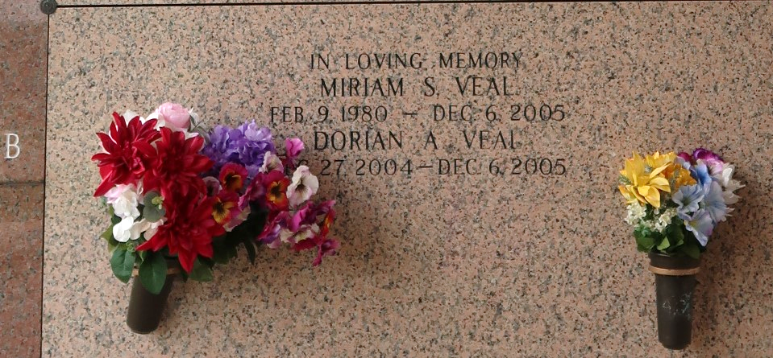
Miram Smith Veal, age 25 and Dorian A. Veal age 11 months and 22 days, departed this life on Tuesday, December 6, 2005 in LaPlace, LA. Wife and son of William P. Veal and the late Miriam Smith Veal. Daughter of Dr. Reverend Joseph and Jessie Mae Smith, Sr. Mother and brother of Kaybien M. Picou. Sister of Dimirtia R. Bethancourt., Zima S. McGee, Joseph, Jr., Parnell, and Kevin Smith. Grandson of Michael and Pat Veal and great grandson of Tom and Ceola Wallace, granddaughter and great grandson of Robert, Rose Lee, and Rozlia Smith, James and Edna Williams and Joseph Warner, Millie Carter and George Veal. Also survived by a host of aunts, uncles, nieces, nephews, cousins and friends. A native of Reserve, LA and resident of New Orleans, LA.
Relatives and friends of the family; pastor, officers and members of New Rescue Mission Baptist Church all neighboring churches are invited to attend the Homegoing Celebration on Saturday, December 17, 2005 at 11:00 a.m. at the above named church, E. 14th St., Reserve, LA. Dr. Reverend Joseph Smith, Pastor, Reverend Jessie McGee Pastor of Deliverance Baptist Church, Officiating. Internment in St. John Memorial Gardens Cemetery, LaPlace, LA. Viewing at the church from 9:00 a.m. until service time. Services Entrusted to Hobson Brown Funeral Home Garyville, LA.

The Times-Picayune, New Orleans, Louisiana
Dec. 16, 2005

