Sylvia May (Knox) Verdun
October 20, 1929 – December 16, 2010
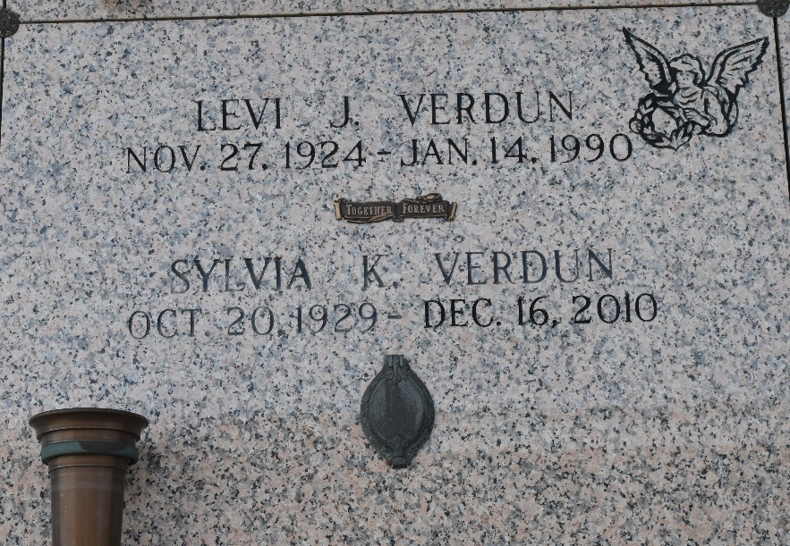

Sylvia May Verdun passed away Thursday, December 16, 2010 in St. Louis MO. Mrs. Verdun was born in Dayton Ohio and lived for over 50 years outside of New Orleans in Kenner and La Place, LA.
Sylvia was preceded in death by her beloved husband Levi. She is survived by her loving daughter, Debbie Childers, and her cherished grandchildren: Alexander and Gabreille Childers. She is also survived by her devoted brothers, Ralph Knox, Kenneth Knox, and her loving sister Delores Bordelon.
Family and friends are invited to a visitation Wednesday, December 22st, 2010 from 9:00 AM to 11:30 AM at Millet Guidry Funeral Home, 2806 W Airline Highway, LaPlace, LA 70068. The Funeral Service will follow at 11:30 AM in the chapel. Interment will follow at St. John Memorial Garden, Laplace LA.

The Times-Picayune, New Orleans, Louisiana
December 21, 2010

