Norma (Weimer) Vial
February 6, 1925 – October 26, 2003
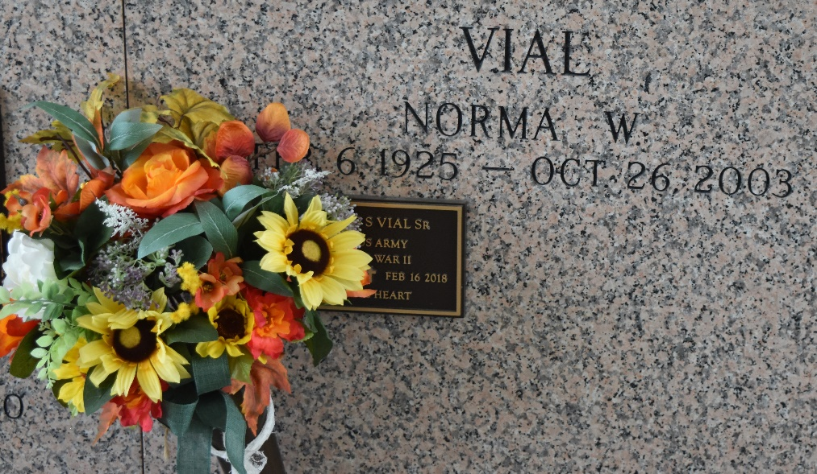

Norma (Red) Weimer Vial, A Homemaker, Died On Sunday, October 26, 2003 At East Jefferson General Hospital.
Mrs. Vial Was A 1943 Graduate Of Destrehan High School, A Member Of The Ascension Of Our Lord Ladies Altar Society, The American Legion Post 195 Ladies Auxiliary, And Was A CCD Teacher In Norco For 20 Years.
Beloved Wife Of Irving (Eph) Vial, Sr. Mother And Mother-In-Law Of Michael And Khanh Vial, Glen And Gail Vial, Richard Vial, Clay And Karen V. Williamson And Stan And Alicia Vial. Daughter Of The Late Joseph Weimer And Lucille Haydel Weimer. Sister Of Ray Weimer, Hazel Anderson, And Russel (Cotton) Weimer And The Late Lucille Lambert, Joseph Weimer, Gertie Walters, Albert Weimer And John (Yut) Weimer. Also Survived By 17 Grandchildren And 5 Great Grandchildren. Age 78 Years. A Native Of Good Hope, La. And A Resident Of Laplace For The Past 22 Years.
Relatives And Friends Of The Family Are Invited To Attend Services. Visitation At Ascension Of Our Lord, 1809 Greenwood Dr., Laplace, La. On Tuesday, October 28, 2003 From 6 Pm To 9 Pm And On Wednesday From 9 Am To 11 Am. Followed By A Mass Of Christian Burial At 11 Am. Burial In St. John Memorial Gardens, Laplace, La. In Lieu Of Flowers, Masses Or Donation To Aol Ladies Altar Society. Millet Guidry Funeral Home In Charge Of Arrangements.

Times Picayune, New Orleans, Louisiana
October 28, 2003

