Ray A. Vice

March 24, 1931 – November 25, 2013

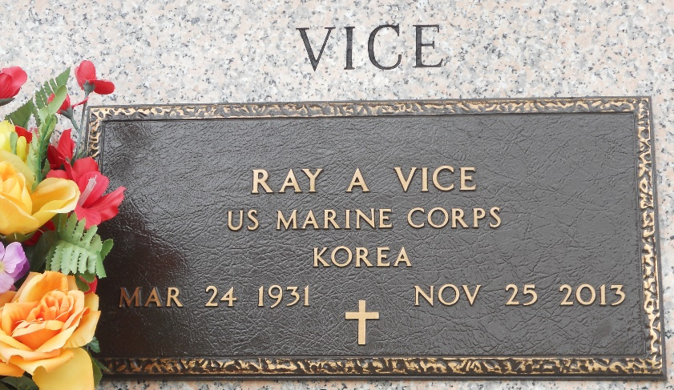

Photo by Team T-Lo

Ray A. Vice died on Monday November 25, 2013. Beloved husband of the late Betty June Millet Vice. Father of Carolyn Vice. Son of the late Sidney and Antoinette Weber Vice. Brother of Joyce Hebert and the late Sidney Vice. Age 82. A native and resident of LaPlace, LA.

Relatives and friends are invited to attend services. Visitation at Millet-Guidry Funeral Home, 2806 W. Airline Hwy, LaPlace, LA on Friday November 29, 2013 from 9:00 am to 11:00 am, followed by Religious Services in the Funeral Home Chapel at 11:00 am. Burial in St. John Memorial Gardens Cemetery, LaPlace, LA.

The New Orleans Advocate, Louisiana

Nov. 27, 2013