Mary Elizabeth (Miller) Vickers
April 24, 1930 – June 11, 2021

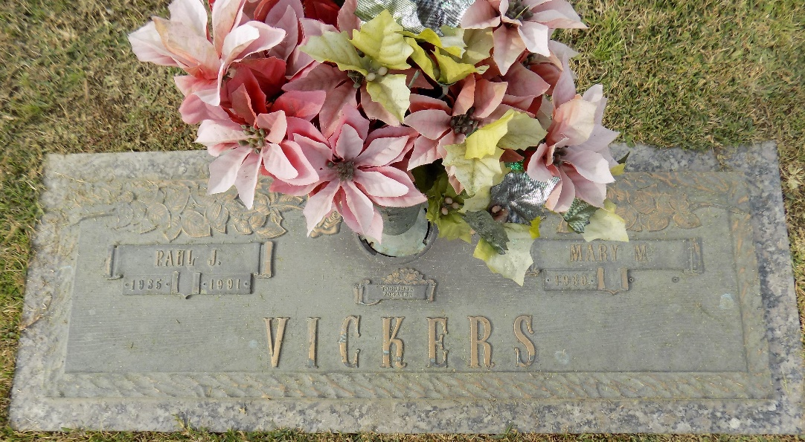

Mary Elizabeth Miller Vickers, a longtime resident of St. Charles Parish was born April 24, 1930 and died peacefully on June 11, 2021 at 91 years of age.
Preceded in death by her husband Paul Vickers, Sr. and son, Paul Vickers, Jr.; parents William B. and Ida Lee Kirkland Miller and sisters, Ruth, Geraldine, and Joyce and brother, Warren B. Miller.
Survived by children Ann Remondet (Cleve), Mary Scuderi (Jim), Mark (Heidi), and longtime daughter in law, Elaine; 11 grandchildren, 19 great grandchildren, and 1 great-great grandchild; many step grandchildren and great grandchildren; 2 sisters, Willie Beatrice Miller Mckey and Clara Miller Mckey and many nieces and nephews.
Relatives and friends are invited to attend the funeral services for Mary at the First Baptist Church of Norco, 626 5th St., Norco, LA, on Saturday, June 19, 2021 at 11 AM. Visitation will begin at 10 AM. Interment to follow at St. John Memorial Gardens in LaPlace. To view and sign the online guestbook please visit www.HCAlexander.com.

Dignitymemorial.com

