Bertha (Becnel) Vicknair
February 13, 1933 – November 15, 2014

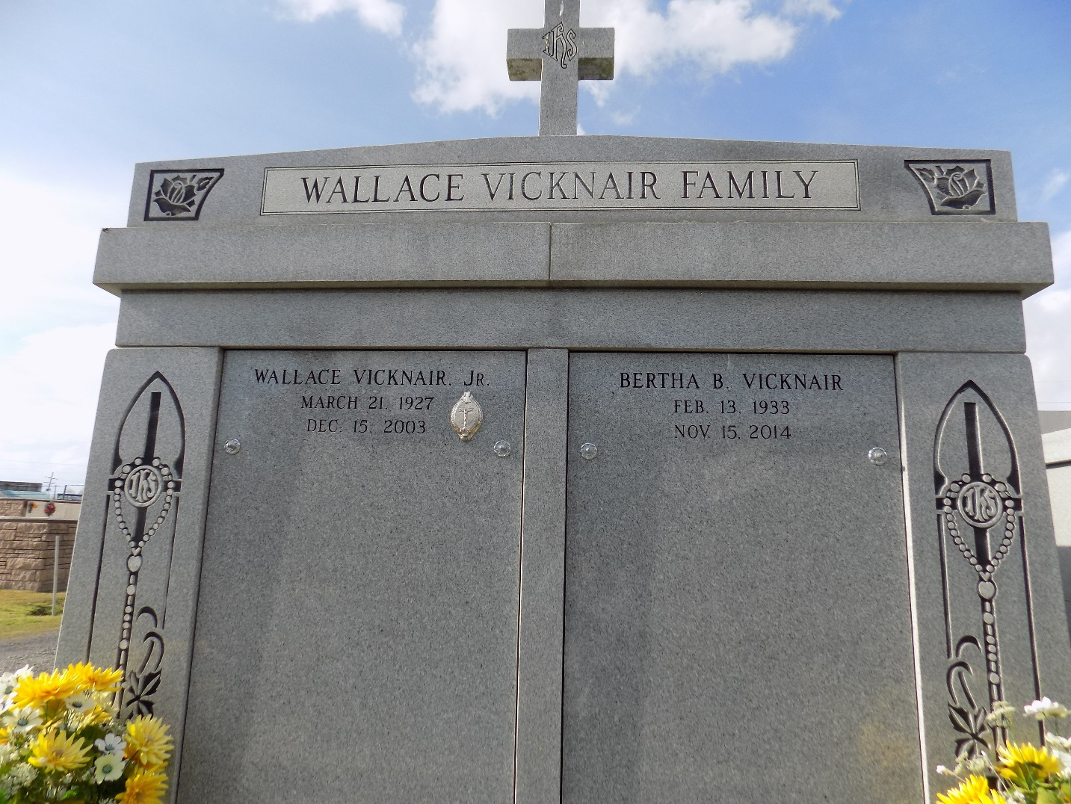

Bertha Becnel Vicknair passed away on Saturday, November 15, 2014. She was 81, a native of Reserve and a resident of LaPlace.
Beloved wife of the late Wallace Vicknair, Jr. Mother of Wayne Vicknair (Carol), Marsha Howard (David), Wallace John Vicknair and Sandra Tamplain (Keith). Daughter of the late Viola Becnel and Pierre Leo Becnel. Sister of Larry Becnel, Pauline Stein and the late Leon, Walter, Donald and Roger Becnel. Grandmother of Lindsay, Erin, Alison, Courtney, Brittany, Jay, Matt, Lacie and Paige. Great-Grandmother of Alyssa, Sam, Alex, Josie, Adeline and Gus. Also survived by many nieces and nephews.
Relatives and friends are invited to attend the Funeral Mass at St. Joan of Arc Catholic Church, 529 W. 5th St., LaPlace on Wednesday, November 19, 2014 at 11:30 a.m. Visitation will begin in church at 9:30 a.m. Interment in St. John Memorial Gardens Cemetery. Arrangements by Millet-Guidry Funeral Home.
Unknown source

