Debra Ann (Vicknair) Vicknair

January 6, 1958 – August 1, 2009

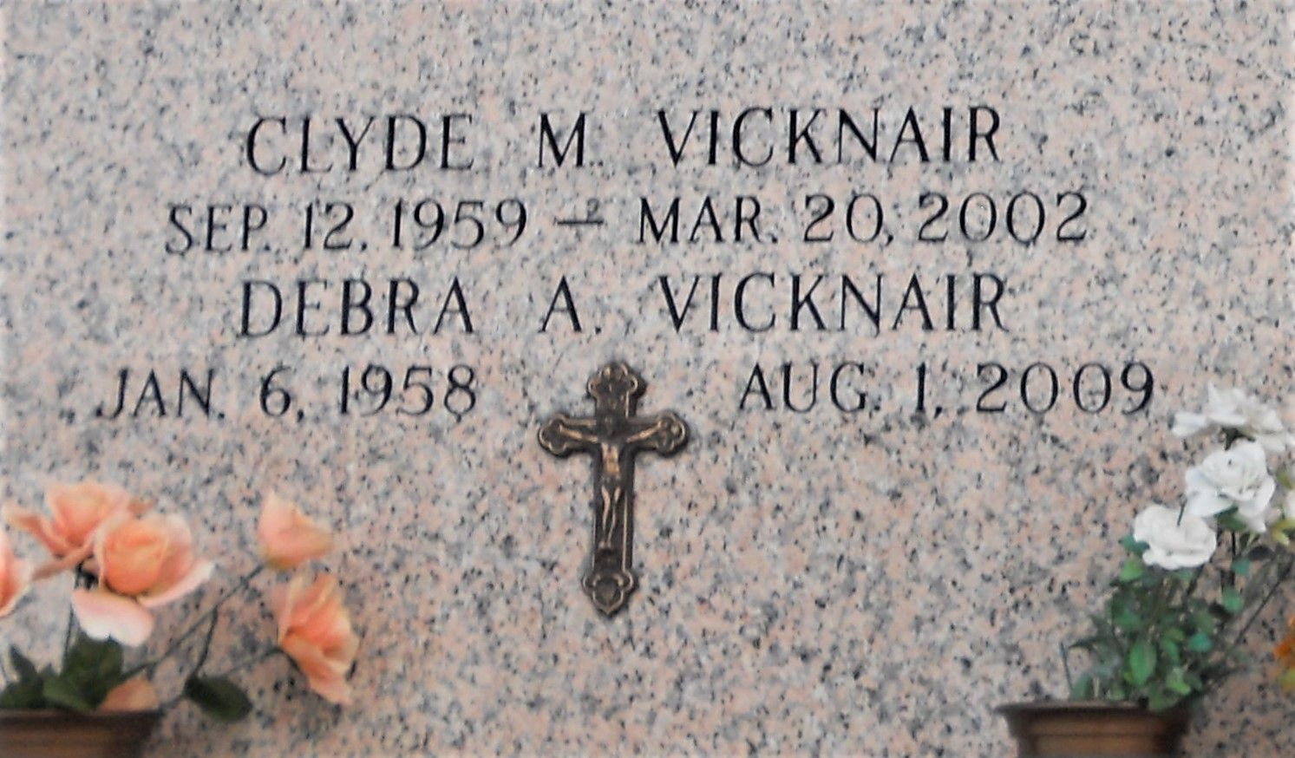

Photo by Team T Lo

Debra Ann Vicknair died Saturday, August 1, 2009, a native of LaPlace, born January 6, 1958. Survived by Husband Nelson Vicknair, parents, Hamilton and Gloria Vicknair, sisters Pamela Aucoin, Charlene Cavalier, Kathleen Calcagno and brother, the late Clyde Vicknair.  
  
Services will be on Friday, August 7, 2009 at St. Joan of Arc Church at 10:00 a.m. with Mass at 11:00 a.m. Interment at St. John Memorial Gardens.

Times-Picayune, The (New Orleans, LA) - Wednesday, August 5, 2009

Contributed by Jane Edson