Gloriajean (Noble) Vicknair
October 2, 1934 – June 5, 2008
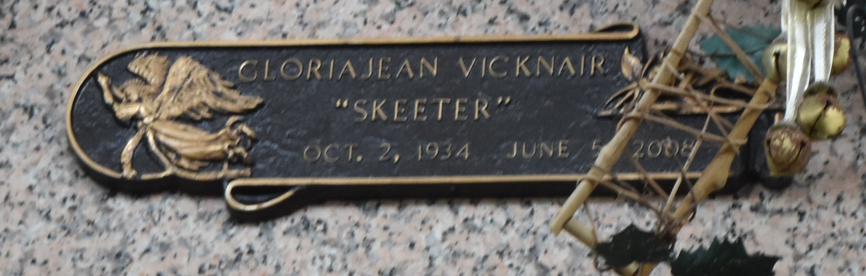

Gloriajean (Skeeter) Vicknair on Thursday, June 5, 2008 at 4:40 p.m.
Beloved wife of the late Ronald (Zorey) Vicknair. Mother of Ronald Vicknair, Jr., Cheryl St. Martin, Jeffery Vicknair and Michael Vicknair. Also survived by 6 grandchildren and 4 great-grandchildren. Age 73 years. A native of Denver, Colorado and a resident of Reserve, LA for the past 37 years.
Relatives and friends of the family are invited to attend services. Visitation at MILLET-GUIDRY FUNERAL HOME, 2806 W. Airline Hwy., LaPlace, LA on Saturday, June 7, 2008 from 9:00 a.m. until 11:00 a.m. Followed by Religious Services at the Funeral Home Chapel at 11:00 a.m. Burial in St. John Memorial Gardens Cemetery, LaPlace, LA.
The Times-Picayune, New Orleans, Louisiana
June 7, 2008

