Hamilton V. Vicknair

December 2, 1927 – February 6, 2018

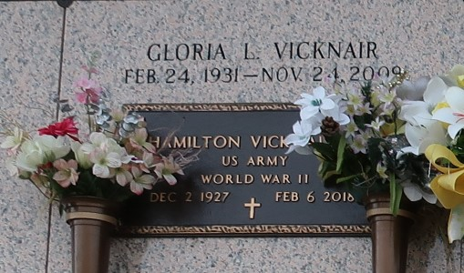

Hamilton V. Vicknair passed away on Tuesday, Feb. 6, 2018, at the age of 90.

He was born in lberville Parish and was a resident of Garyville. Hamilton retired from Shell Oil after 37 years of service. He also served as a United States Marine.

He was the beloved husband of the late Gloria Levet Vicknair; father of Pam Aucoin (Helman), Charleen Cavalier (Donald), Kathleen Calcagno (David), the late Debbie Vicknair, the late Clyde Vicknair; grandfather of Keith Aucoin (Barbara), Gary Cavalier, Ginger Guillot (Lones), Shawn Cavalier, Danielle Coburn (Michael) and David Jr. Calcagno. He is also survived by six great grandchildren and one great great grandchild.

Relatives and friends are invited to attend the Funeral Service at St. Hubert Church, 176 Anthony F. Monica St. in Garyville on Thursday, Feb. 15 at 11 a.m. Visitation is from 9 until 11 a.m. Interment is in St. John Memorial Gardens Cemetery.

L’Observateur, LaPlace, Louisiana

Thursday, February 8, 2018