Janet (Barre) Vicknair
August 24, 1936 – March 8, 2024
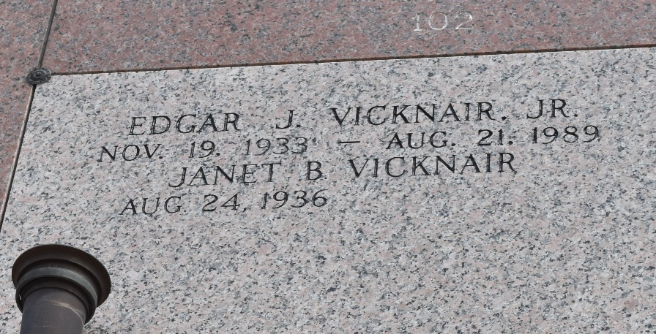

Janet Barre Vicknair passed away peacefully on Friday, March 8, 2024 at the age of 87. She was a native of Reserve, LA and resided in Gonzales, LA for the past several years to be near two of her daughters. Janet’s passion was Jesus and she loved telling everyone how he could become their personal Lord and Savior.
Janet is preceded in death by her husband Edgar J. Vicknair Jr; parents James Barre Sr. and Jeanne Madere Barre LeBoeuf; brothers James Barre Jr. and John Gary Barre; and granddaughter Amanda Forsythe.
She will be sadly missed by her six children, Angela Solomon (Michael), Gail Forsythe (Claude “Blue”), Cindy DeLacerda (Billy), Edgar Vicknair III (Jo Ann), Melanie Maurin (Ozzy), and Karen Richoux (Ralph); along with her 14 grandchildren and 32 great grandchildren; and siblings Joan Vicknair, Jerry Barre, and Sidney LeBoeuf III.
As per Janet’s wishes, a private gravesite gathering will take place. The family would appreciate your thoughts and prayers during this time.

Ascension Funeral Home, Gonzales, Louisiana
May 16, 2024

