John L. Vicknair Jr.
May 22, 1933 – December 31, 1999
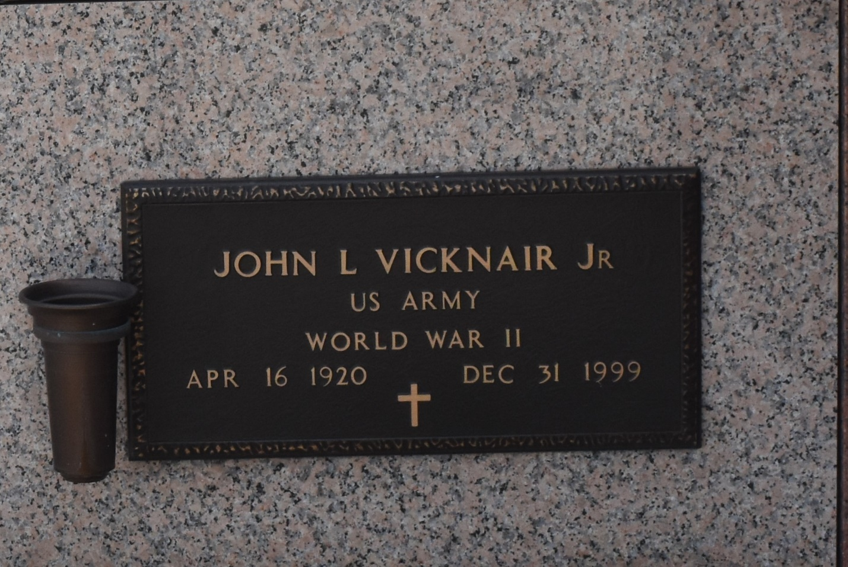

LAPLACE - John L. "Vic" Vicknair Jr., 79, a native and resident of LaPlace, died Dec. 31.

He was the husband of the late Marie Hutchinson Vicknair and father of Deborah Hudson, Lisa White, John L. "Johnny" and John Paul Vicknair and the late Robin Ann Vicknair. He was also the son of the late John L. and Marie Keller Vicknair and brother of Carol BeBautte, Lazinna Guidry, Carmen Wilson, Alice Schultz, Lois Saucier, Jean "Buddy" Vicknair and the late Rosemary Madere. He is also survived by seven grandchildren.

Services were held Jan. 4 in the chapel of Millet-Guidry Funeral Home, LaPlace, with interment at St. John Memorial Gardens, LaPlace.
L'Observateur, LaPlace, Louisiana
January 5, 2000

