Kyles James Vicknair
January 15, 1991 – November 23, 2020
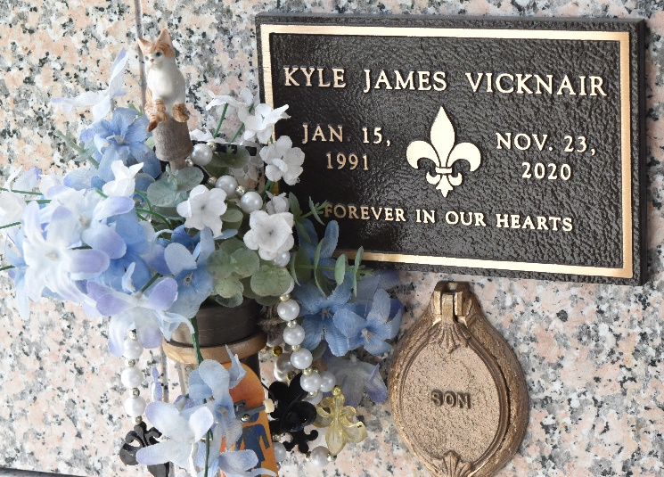

Kyle James Vicknair passed away at his home on Monday, November 23, 2020 at the age of 29. He was born in New Orleans and resided in LaPlace. Kyle was a 2009 Graduate of St. Charles Catholic and also attended Louisiana State University. He worked with Prudhomme's Maintenance and also painting with Daley's Drywall Company.
Beloved son of Regina Lemoine Vicknair and Daniel "Danny" Vicknair, Jr. He is also survived by his grandmother, Virginia Villemarette Lemoine and preceded in death by his beloved "PaPa" Dalton J. Lemoine, beloved "Paw Paw" Daniel A. Vicknair, Sr. and his cherished "Maw Maw" Mable Laiche Vicknair. Nephew of Marsha Daley and the late Richard "Dickie" Daley, Mary and Robert Millet, his godfather Jeffery and Kristie Lemoine. Also survived by his cousins, Chris, Mandy, Jake, Jenna, and Kaylyn and preceded in death by his cousin and godmother, Kimberly Daley Levatino.
Relatives and friends are invited to attend the Memorial visitation and service at Millet-Guidry Funeral Home, 2806 W. Airline Hwy, LaPlace on Tuesday, December 1, 2020. The visitation will be held from 9:00 a.m. to 11:00 a.m. with the service to immediately follow at 11:00 a.m. Inurnment will be held in St. John Memorial Gardens Cemetery. Kyle would want you to feel comfortable, so please dress in your casual attire, jeans and Saints attire are welcomed.
Millet-Guidry Funeral Home, LaPlace, Louisiana
November 26, 2020

