Lesley A. Vicknair
March 30, 1932 – September 26, 2021
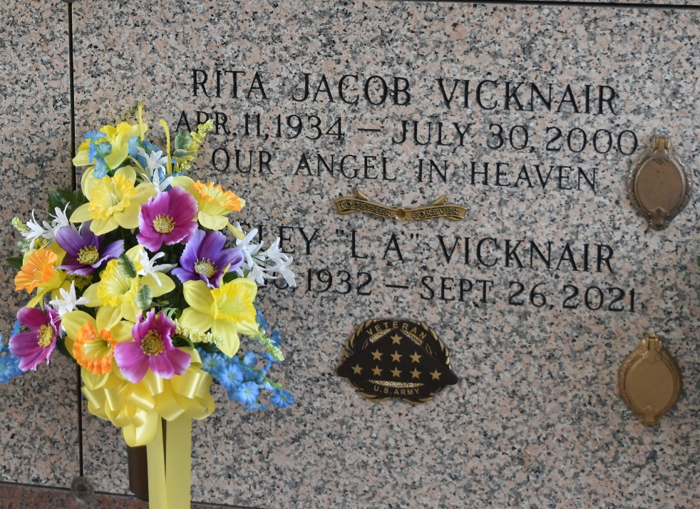

Lesley A. "L.A." Vicknair passed away on Sunday, September 26, 2021 at the age of 89. He was a lifelong resident of Laplace, LA.
He is survived by children, Bryan Vicknair (Margie), Donna Caronna (G.J.), and Leslie Granier (the late, Barton); grandchildren, Garland Caronna (Kristin), Chris Caronna (Whitney), Amanda Caronna, Jeremy Granier (Stephanie), and Michelle Granier; great-grandchildren, Carly and Cameron Caronna, Veyda and Josie Caronna, Makenzie Granier, and Everett McLaughlin; and family friend and companion to Leslie Granier, John Bedard.
L.A. is preceded in death by the love of his life, Rita Jacob Vicknair; parents, Wallace and Elvina Brou Vicknair; siblings, Whitney Vicknair, Maria V. Duhe, Ester V. Millet, Wallace Vicknair, Jr., and Roy Vicknair, Sr.; and son-in-law, Barton Granier.
L.A. proudly served his Country in the United States Army during the Korean War. He later worked for Kaiser/LaRoche for 33 years. He enjoyed hunting, fishing, and shrimping.
Relatives and friends are invited to attend the funeral service at St. Joan of Arc Catholic Church, 529 W. 5th Street, Laplace, LA on October 1, 2021 from 11:00 AM to 1:00 PM followed by a Mass of Christian Burial. Interment will take place at St. John Memorial Gardens Cemetery in Laplace, LA.
Rose Lynn Funeral Home, Lutcher, Louisiana

