Robin Ann Vicknair
March 20, 1965 – January 11, 1976
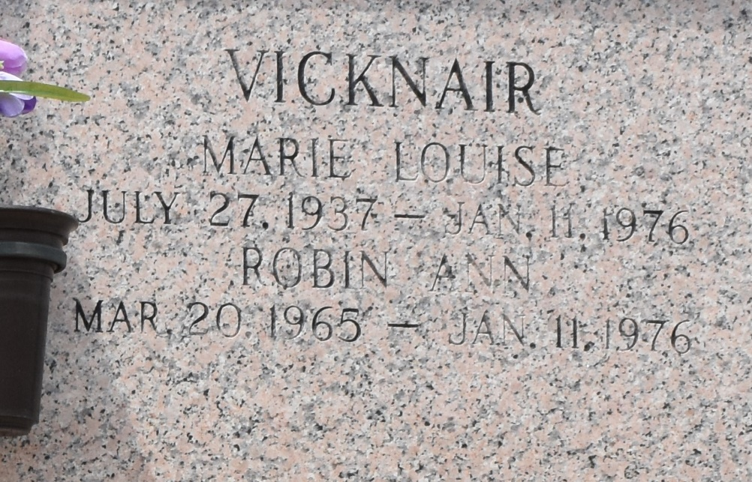

ROBIN ANN VICKNAIR
Funeral services for Robin Ann Vicknair of LaPlace were held Wednesday, Jan. 14, from the St. Joan of Arc Catholic Church, LaPlace. Interment was in St. John Memorial Gardens there.
She died about 5:17 p.m., Sunday, Jan. 11, when the car in which she was a passenger plunged into a canal alongside the Airline Highway in Ascension Parish. She was 10 years old.
She is survived by her father, John L. Vicknair and brothers and sisters, Johnny, Deborah, Lisa and John Paul Vicknair, all of LaPlace.
L’Observateur, LaPlace, Louisiana
Thursday, January 15, 1976, p. 4

