Roy A. Vicknair, Sr.

December 8, 1929 - June 18, 2021

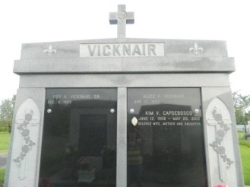

Roy A. Vicknair, Sr. passed away on Friday, June 18, 2021 at the age of 91. He was a native and lifelong resident of LaPlace, LA. Roy proudly served his Country in the U. S. Army during the Korean War. He later worked for Shell Oil Refinery in Norco for 34 years.   
 Beloved husband of 65 years to Alice Faucheux Vicknair. Loving father of Roy A. Vicknair, Jr. (Severine), Robin V. Hoffmeister (Brad), and the late Kim V. Capdeboscq (Jean). Grandfather of John Capdeboscq, Chad Capdeboscq (Jessica), Fabian Weiland, and Natascha Scott (Brad). Great grandfather of Zoe Capdeboscq, and Bowen Capdeboscq. Son of the late Wallace Vicknair and Elvina Brou Vicknair. Brother of Leslie Vicknair (the late, Rita), and the late Whitney Vicknair (Annabelle), Maria V. Duhe (Armand), Ester V. Millet (Felix), and Wallace Vicknair, Jr. (Bertha). Also survived by many nieces and nephews.  
 Relatives and friends are invited to attend the Funeral Service at St. Joan of Arc Catholic Church, 529 W. 5th Street, LaPlace on Wednesday, June 23, 2021. Visitation will be held in church from 10:30 a.m. to 12:00 p.m. with the Funeral Mass to immediately follow at 12:00 p.m. A Private Interment will follow in St. John Memorial Gardens Cemetery, LaPlace, LA.

Millet-Guidry Funeral Home, LaPlace, Louisiana

June 22, 2021