Wallace Vicknair, Jr.
March 21, 1927 – December 15, 2003

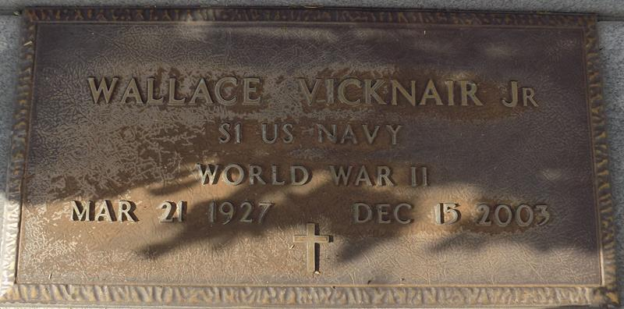

Wallace (June) Vicknair, Jr. On Monday December 15, 2003 At 11 Am. Beloved Husband Of Bertha Becnel Vicknair. Father Of Wayne Vicknair, Marsha Howard, Wallace (Johnny) Vicknair And Sandra Tamplain. Son Of The Late Wallace Sr. And Elvina Vicknair. Brother Of Roy And Leslie Vicknair, Esther Millet, And The Late Whitney Vicknair And Maria Duhe. Grandfather Of Lindsay, Erin, Jay, And Matt Vicknair, Alison, Courtney, And Brittany Howard And Lacie And Paige Tamplain. Age 76, A Native And Resident Of Laplace.
Relatives And Friend Of The Family Are Invited To Attend Services. Visitation Millet-Guidry Funeral Home, 2806 W. Airline Hwy, Laplace, On Tuesday, December 16, 2003 From 5pm To 9pm. And On Wednesday From 8:00 Am - 9:45 Am. Followed By Religious Services At St. Joan Of Arc Catholic Church, Laplace At 10:00 Am. Burial In St. John Memorial Garden, Laplace.
Times Picayune, New Orleans, Louisiana
December 16, 2003

