Chester J. Victor Jr.
1957 – September 7, 2017

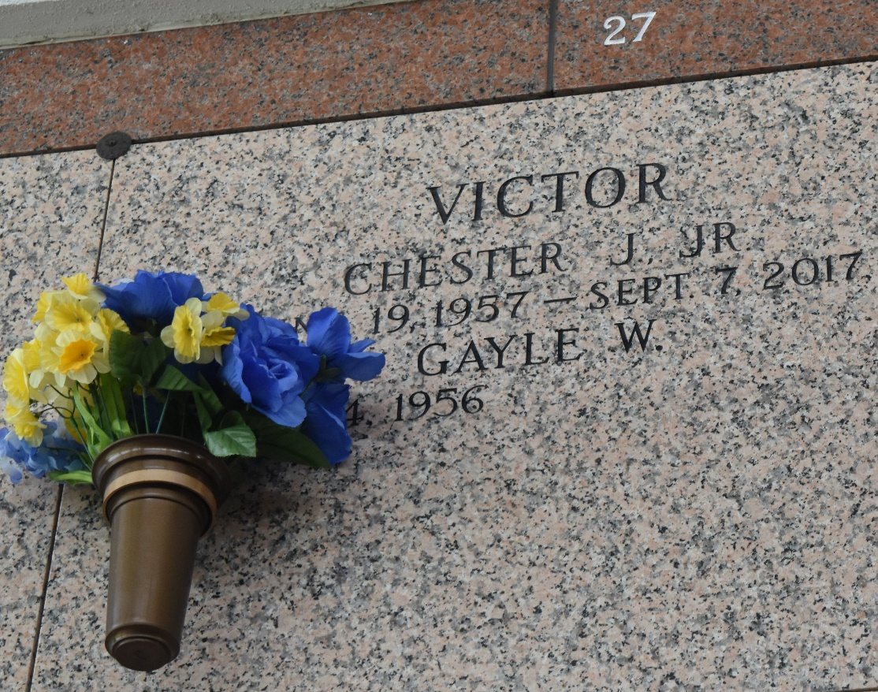

Chester J. Victor Jr., 60, passed away on Thursday, September 7, 2017.
Husband of 40 years to Gayle W. Victor. Son of Myrtle and the late Chester Victor Sr. Survived by his children, grandchildren, great grandchildren, siblings, and a host of other relatives and friends.
Viewing on Friday, September 15, 2017 from 5:00 p.m. – 7:00 p.m. Funeral Service on Saturday, September 16, 2017 at the Greater New Plymouth Rock Baptist Church, 110 NW 13th St Reserve LA 70084 at 11:00 a.m. Viewing from 9:00 am until service time. Rev. David Carter Pastor officiating. Internment in St. John Memorial Gardens, Laplace, LA.
The New Orleans Advocate (Louisiana)
Sep. 14 to Sep. 16, 2017

