Harlan Rand Victor Sr.
April 23, 1962 – April 6, 2021
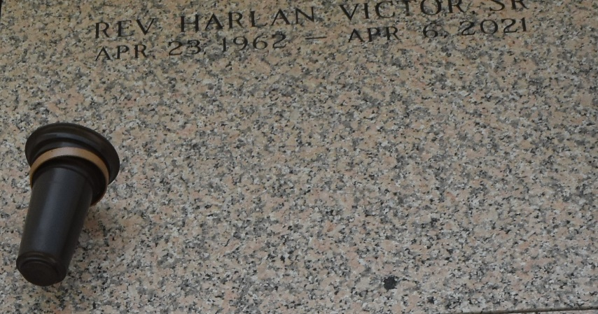
Harlan Rand Victor Sr. was born on April 23, 1962 to the union of Myrtle Victor and the late Chester Victor Sr. He accepted Jesus Christ as his personal savior at an early age and was baptized in 1971 by the late Rev. James Robinson of Rescue Mission Baptist Church. He departed this life on Tuesday, April 6, 2021 at his home in Marksville, LA.
Harlan leaves to cherish his memories his loving mother, Myrtle Victor; his children Harlan (Brittany) Victor Jr., Melinda (Quinton) Kemper, and Demetrius Victor; Children he reared as his own Herbert Surgent and Fantah Surgent; his siblings, Thaddeus (Reonda) Victor, Errol Victor, Wandalyn (Charles) Ursin, Jacqueline Victor, Elvera Victor, Dena (Eldridge) Moll; a sister in law, Gail Victor; a grandchild Roman Victor; an aunt Phyllis Williams, and an uncle Hilton Farlough; Goddaughter Rachel Stewart; a multitude of nieces, nephews, cousins, special friends, and others that he loved dearly.
Harlan was preceded in death by his father Chester Victor Sr.; brothers Chester Victor Jr. and Kenneth Victor; grandparents Earl and Florence (Driver) Farlough and Paul and Celia (London) Victor.
Family and friends are invited to the home going celebration on Saturday, April 17, 2021 at 11 a.m. at New Wine Christian Fellowship, 1929 W Airline Hwy, Laplace, LA 70068. Reverend A. L. Johnson officiating. Visitation from 9 a.m. until 11am. Interment: St. John Memorial Gardens, 2205 W Airline Hwy, Laplace, LA 70068. Viewing will be held Friday, April 16, 2021 from 3 p.m. until 5 p.m. at Bardell's Mortuary, 3856 LA-44, Mt. Airy, LA 70076. Due to COVID-19, masks and social distancing will be strictly enforced. Services entrusted to Bardell's Mortuary. Information: (985) 535-6837. In lieu of flowers, the family requests donations be made to CASO: Harlan Victor Scholarship: P.O. Box 12702, Alexandria, LA 71315-2702.
Times Picayune, New Orleans, Louisiana
April 15-17, 2021

