Myrtle (Farlough) Victor
February 6, 1934 – March 22, 2022
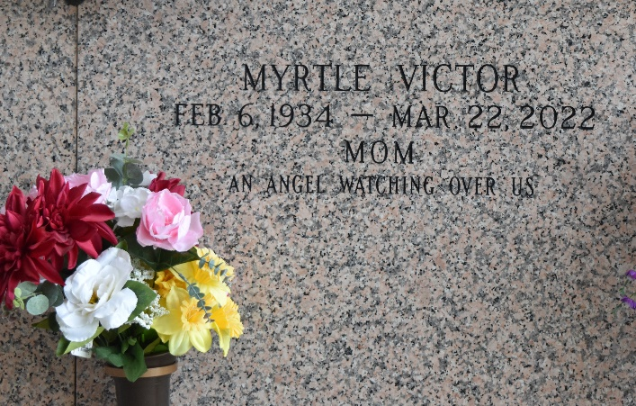
Myrtle Farlough Victor, 88 years of age; a native of Mt. Airy, LA. Resided at the time of her illness & transitioning peacefully to the father, under the care, in the home of her daughter (Jacqueline) of Hammond, LA., until March 22, 2022. Myrtle was born February 6, 1934; to the late Earl James Farlough, Sr. & Florence Driver Farlough; She was reared by her stepmother Sylvia Farlough, after the passing of her mother.
Myrtle accepted the Lord at an early age, under the Pastorship of Reverend JJ Farlough Sr. of St. John Baptist Church Mt. Airy, LA. Where she was a devoted and committed member, serving in various areas of ministry. During her illness, she remained faithful, serving God under the leadership of her daughter, Apostle Dr. Jacqueline Victor “Fruit of the Righteous Ministry” where she remained faithful. Myrtle was a licensed practical nurse for over 40 years, using her skills and abilities to help others; worked at various healthcare facilities; she was also an entrepreneur. Owner of “Victory Home Health” for over 10 years; Dena’s Grocery and Game Room; Hair and Barber Salon; Service Station Etc., She was a blessing to many; always giving and helping those in need; never ceasing to express and communicate pearls of wisdom; Golden Nuggets for life.
Myrtle was married to the late Chester Joseph Victor, Sr. Myrtle was blessed and gifted with nine children, Wandalyn (Charles, Jr.) Ursin, Elvera Victor, Jacqueline Victor, Thaddeus (Reonda) Victor, Dena (Eldridge) Moll, Errol Victor, the late Kenneth, Chester J. (Gayle), and Harlan Victor. 36 grandchildren and over 80 great grandchildren; to include great great grandchildren.
Myrtle is survived by 3 siblings; brother Hilton (Faith) Farlough; sisters Phyllis Williams, Greta Farlough, A multitude of nieces, nephews, cousins, special friends, and others that loved her dearly. Myrtle is preceded in death by her husband, Chester J Victor, Sr., Her sons Chester J. Victor, Jr., Kenneth Avery Victor and Harlan Rand Victor, Sr., her parents, Earl J. Farlough, Sr. and Florence Driver Farlough, siblings, Earl J. Farlough, Jr. Milton Farlough, Hersey Farlough, Earline Farlough Browser, Barbara Mae Farlough Rogers.
Relatives and friends of the family, Pastors, Officers, and Members of Milesville Church of God in Christ and all neighboring Churches are invited to attend the Celebration of Life on Saturday, April 9, 2022, 10:00 am at Milesville Church of God in Christ, 129 Apple Street, LaPlace, LA 70068. Bishop Ronald Frank, Pastor-Officiant. All in attendance must adhere to the CDC guidelines for COVID-19 and practice social distancing. Visitation at the above-named church 8:00 am until time of service. Interment St. John Memorial Gardens, 2205 W. Airline Hwy, LaPlace, LA 70068. Final Arrangements entrusted to Patrick H. Sanders Funeral Home & Funeral Directors, Inc. 605 Main Street, LaPlace, LA 70068. For information 985-359-1919.
The Patrick H. Sanders Funeral Home, LaPlace, Louisiana

