Patricia Ann Vinet
April 3, 1949 – December 8, 2008
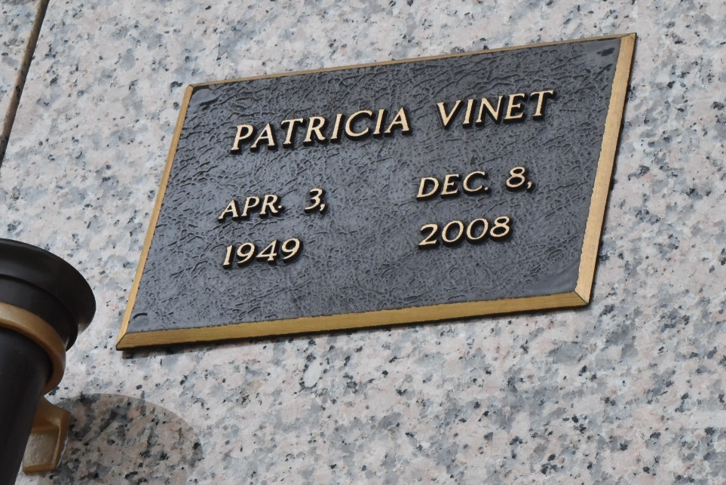

Patricia Ann Vinet, age 59, entered into eternal rest on Monday, December 8, 2008.
Relatives and friends of the family are invited to her Memorial Service on Friday, December 12, 2008, 10:30am at St. Joan of Arc Catholic Church, 529 West 5th Street, LaPlace, LA. Burial will be private.
She leaves to cherish her most precious memories her loving husband, Paris Vinet, Sr.; 3 children: Ellen, Lisa and Christopher Vinet; 3 stepchildren: Paris Jr., Keith and Kenney Vinet; and a host of grandchildren, other relatives and friends.
Special thanks to River Parishes Casino for all their Love and support during our time of bereavement.
Services entrusted to the caring staff of: Professional Funeral Services, Inc. "Divine Service for a Divine People" 605 Main Street LaPlace, LA 70068 (985) 652-1730

The Times-Picayune, New Orleans, Louisiana
Dec. 11, 2008

