William Wactor
July 25, 1939 – March 13, 2012

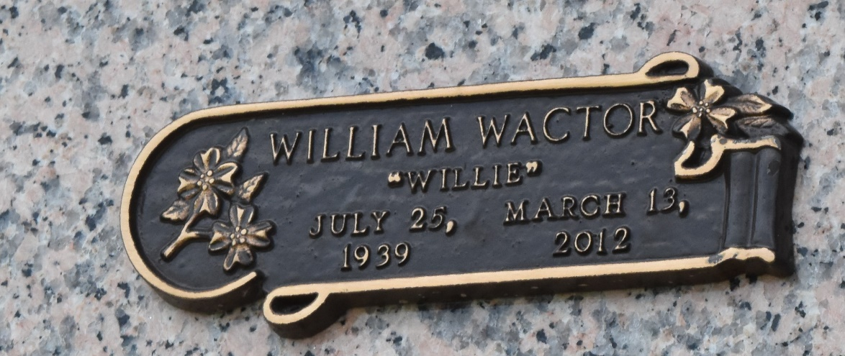

William (Willie) Wactor Jr. passed away on Tuesday March 13, 2012. Beloved husband of Glenda Weber Wactor for 46 years. Father of Kyle and Dawn Wactor, Tish St. Martin (Paul) and the late John Westley Wactor. Grandfather of Jeremy and Kyla Wactor, Gabrielle, Alexander and Victoria St. Martin. Son of Bonnie Wactor and the late William Wactor. Brother of Bobby, George and Johnnie Wactor and the late David Wactor. Age 72. A native of New Orleans and a resident of LaPlace, LA.
Relatives and friends also employees of Avondale Container Yard, Intermodal Railroad Division and Steamship Industry are invited to attend services. Visitation at Millet-Guidry Funeral Home, 2806 W. Airline Hwy. LaPlace, LA on Thursday March 15, 2012 from 5:00pm to 9:00pm, followed by Mass on Friday at St. Joan of Arc Catholic Church, 529 W. 5th St. LaPlace, LA at 11:00am. Burial to be private at a later date.
The Times-Picayune, New Orleans, Louisiana
Mar. 14 to Mar. 16, 2012

