Stella (Nickelbrough) Wade
August 16, 1937 – January 8, 2022

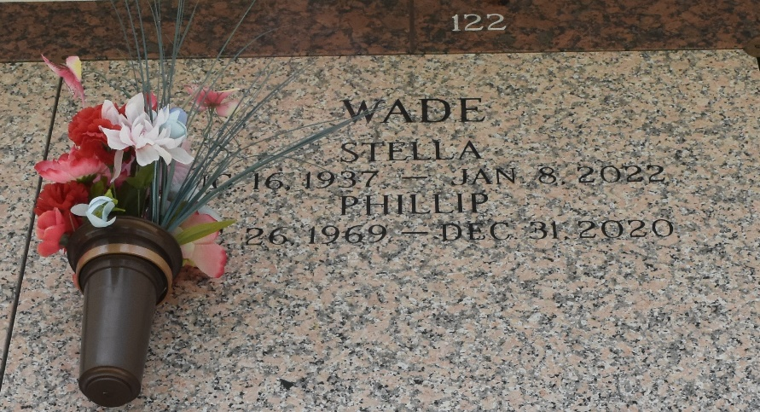

Stella Wade passed away on Saturday, January 8, 2022 at the age of 84. She was a native of Beaumont, Texas and a resident of Reserve, LA. She is preceded in death by her parents, Phil and Stella Nickelbrough; and her 4 brothers and 6 sisters. Beloved mother of James "Cutter" Perkins, Edward Mullins, Stella "Jeanetta" Ange (Charlie), Walter Wade III (Danielle), Annie Wade, Phillip Wade (Rhonda), Denise, and Loretta Wade (Jimbo). She was the Ex-wife of Walter Wade Jr. Loving grandmother of 23 grandkids and great grandmother of 26 great grandkids. She was blessed to be loved by so many and will be missed by all.
A Graveside Service will be held on Tuesday, January 18, 2022 at 10:00 a.m. at St. John Memorial Gardens Cemetery, LaPlace. In lieu of flowers, please consider a donation in her memory to St. Jude Children's Research Hospital, 501 St. Jude Place, Memphis, TN 38105.
Millet-Guidry Funeral Home, LaPlace, Louisiana
January 16, 2022

