Freida (Webb) Waguespack

February 18, 1955 – January 30, 2014

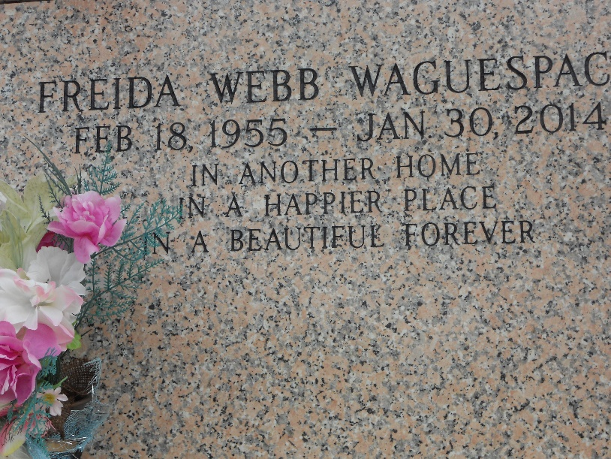

Photo by Team T-Lo

Freida Webb Waguespack died on Thursday January 30, 2014. Beloved mother of Jennifer Webb and Melissa Webb. Daughter of the late Weldon (Curly) and Wanda Webb. Sister of Rita Cambre, Nida Triche, Pam Leslie, Peggy Stell, Kelli Mayer and Mary Vicknair. Age 58. A native of Texas and a resident of LaPlace, LA.

Relatives and friends are invited to attend services. Visitation at Millet-Guidry Funeral Home, 2806 W. Airline Hwy., LaPlace, LA on Thursday February 6, 2014 from 8:00am to 10:00am, followed by Religious Services in the Funeral Home Chapel at 10:00am. Burial in St. John Memorial Gardens Cemetery, LaPlace, LA.

The New Orleans Advocate, Louisiana

Feb. 4 to Feb. 5, 2014