Huey Joseph Waguespack
August 8, 1937 – April 16, 2009

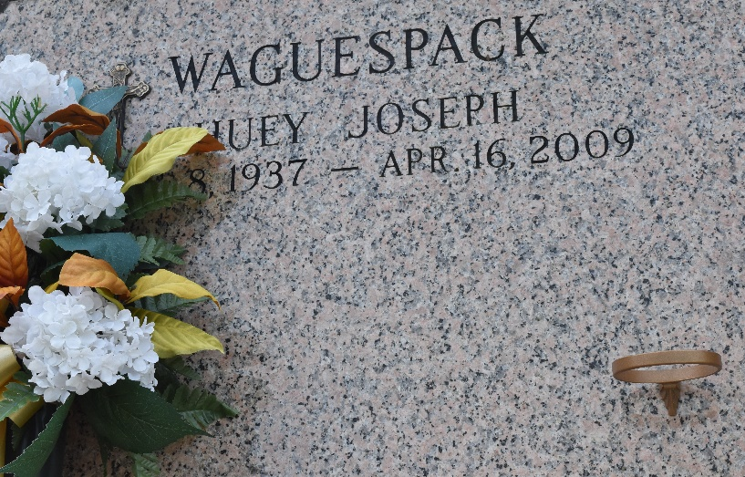

Huey Joseph Waguespack, a loving husband, father, grandfather, brother and friend, died on Thursday, April 16, 2009 at East Jefferson General Hospital after complications from surgery.
Visitation will be at Millet-Guidry Funeral Home, 2806 W. Airline Hwy., LaPlace, La. on Friday, April 17, 2009 from 5:00pm to 9:00pm. A Rosary will be said at 7:30pm. Visitation on Saturday, April 18, 2009 at Ascension of Our Lord Catholic Church, 1900 Greenwood Drive, LaPlace, La. from 9:30am to 11:30am followed by a Mass of Christian Burial at 11:30am. Internment will be in St. John Memorial Gardens Cemetery, Airline Hwy., LaPlace, La.
Huey was born in Remy (Paulina), La. to Joseph Benjamin Waguespack and Thelma Marie Delatte Waguespack on August 8, 1937. He married Juanita Nettie Eagle Eye on June 19, 1958, enjoying 50 years of marriage. They had 1 daughter and 2 sons, and 7 grandchildren. He is survived by his wife; children: Karen W. Schexnayder and her husband, Lloyd and their children, the late infant Chad, Lindy S. Smith and her husband, Andy and Christa S. Veillon and her husband, Greg; Brent J. Waguespack and his wife, Vivian and their children: Ashley and Casey; and Troy E. Waguespack and his wife, Doreen, and their children: Shelby and Lane. He is also survived by his brothers: Percy and Joseph, Jr.; and his sisters: Ruby and Madaline. He was preceded in death by his parents.
Huey was an avid New Orleans Saints fan and gardener. He was a charter member of Ascension of Our Lord Catholic Church. Huey was a member of the American Legion, Ascension of Our Lord Knights of Columbus Council 2693 and Archbishop Blenk Assembly 318. He retired from Entergy.

Times-Picayune, New Orleans, Louisiana
Apr. 17, 2009

