Lynn Waguespack
June 2, 1944 – May 15, 2023

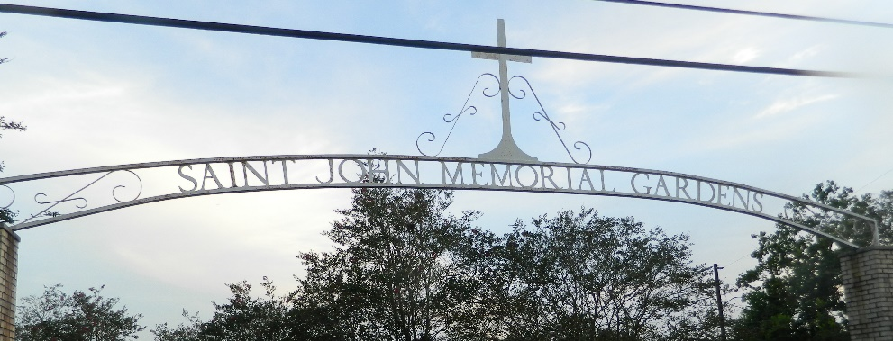

Lynn Waguespack passed away on Monday May 15, 2023, with his children by his side, at the age of 78. He was born in New Orleans, LA and resided in Norco, LA, for over 50 years.
Beloved husband of the late Shirley Waguespack. Loving father of Connie Waguespack (Julie), Carol Guedry (Kenny), Libby Ferraro (Nicky), and Linette Walker (Johnny). Grandfather of Brittany (Chad), Jeremy (Katie), Dylan (Ariel), Brandon (Melissa), Taylor (Garrett), Maggie, Kaci, Jessica (Max), and Jade (Corey). Great-grandfather of 11 great-grandchildren. Son of the late Herbert and Frances Waguespack, Sr. Brother of Rosalie Pitts, and the late Herbert Waguespack, Jr., Jeanette Wood and James Waguespack.
Relatives and friends are invited to attend the funeral on Thursday, May 18, 2023, at Rose Lynn Funeral Home, 1870 Cabanose Ave., Lutcher, LA 70071. Visitation will be held from 11:00 a.m. to 2:00 p.m. followed by a Funeral Service at 2:00 p.m. Burial to immediately follow the services at St. John Memorial Gardens Cemetery in LaPlace, LA.
Rose Lynn Funeral Home, Lutcher, Louisiana

